Sidonia Beef.Naturally Open Gate Event
Expression of Interest Form

Come and see first-hand how Sidonia beef farmer Sam White is using holistic management principles to plan rotational grazing, improve soil health, grow more grass and boost animal performance.

Places are strictly limited. EOIs should be submitted to Ashley Rogers, Goulburn Broken CMA by 10 am Monday 25 September 2017 via any of the methods below:
Email: ashleyr@gbcma.vic.gov.au
Post: PO Box 124, Benalla VIC 3672
Successful applicants will be notified by Tuesday 27 September 2016. For further enquiries please contact Ashley on the email above or phone 0357 647 507.

Expression of Interest Questionnaire

Title: _______First Name: _____________________ Surname:_______________________________________

Postal Address: _______________________________________________________________________________________________
_______________________________________________________________________________________________
_______________________________________________________________________________________________

Phone: __________________________________

Email:_________________________________________________________________________________________

Occupation: ____________________________________________________________________________________

Industry: _______________________________________________________________________________________

Dietary requirements (for catering purposes): __________________________________________________________

What do you hope to get out of this event (e.g. topics of interest)?
_______________________________________________________________________________________________
_______________________________________________________________________________________________
_______________________________________________________________________________________________

Due to limited site access, entry to the open day is via bus or special arrangement. Please select your preferred bus pick-up location (exact details to be confirmed) or request to drive yourself:
- Benalla – 8.00 am
- Euroa – 8.35 am
- Seymour – 9.25 am
- Tooborac – 10.10 am
- Bendigo – 8.30 am
- Harcourt – 9.00 am
- Kyneton – 9.40 am
- Drive yourself
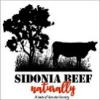
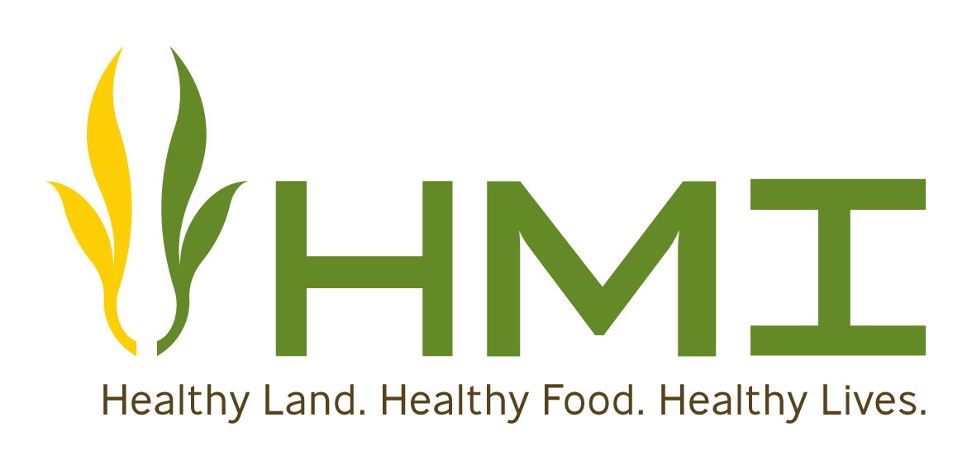
This event is supported by funding from the Australian Government’s National Landcare Programme and Holistic Management International, hosted by Sidonia Beef.Natually in partnership with the Goulburn Broken CMA, North Central CMA and Inside Outside Management.

