## Notice of Revocation

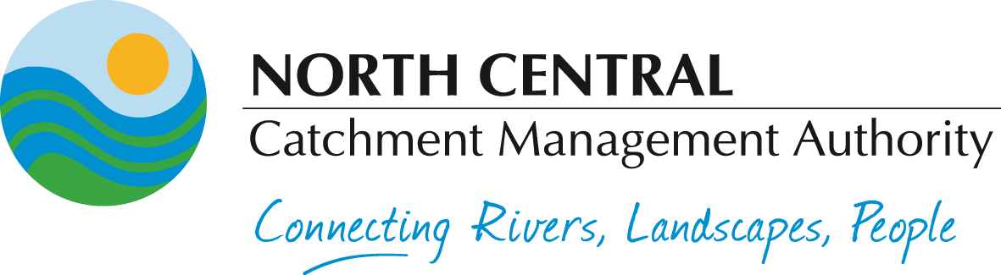

***Water Act 1989***

NORTH CENTRAL CATCHMENT MANAGEMENT AUTHORITY

Pursuant to section 203 of the ***Water Act 1989*,** notice is hereby given that the North Central Catchment Management Authority intends to revoke existing flood levels for Greater Bendigo and Strathfieldsaye as shown on Plans 135930-135935, 135937-135967 and 147047A.

The flood levels are being revoked as they have been superseded by the Greater Bendigo Planning Scheme.

The flood level plans to be revoked are available for inspection at the City of Greater Bendigo Council office, [*15 Hopetoun Street, Bendigo*] and North Central Catchment Management Authority office, [*628-634 Midland Highway, Huntly*].

Prior to revoking flood levels for Greater Bendigo and Strathfieldsaye, any person may, within 6 weeks of the date of publication of this notice, make a submission regarding the proposed revocation. Written submissions should be marked “Revocation Submission” and be addressed to the Chief Executive Officer, North Central CMA, [*PO Box 18 Huntly Victoria 3551*]. Interested persons may visit the Authority’s website ([www.nccma.vic.gov.au](http://www.nccma.vic.gov.au)) for further information or contact North Central CMA on (03) 5448 7124 prior to the closing date for submissions.

Brad Drust

Chief Executive Officer