Regional Roundtables

2018-19 Summary
The North Central Catchment Management Authority (CMA) has a long history of creating natural resource management (NRM) partnerships and programs that deliver lasting change.
Communities are at the centre of all we do. During February-March 2019, communities from across the region had opportunities to identify and discuss, through Regional Roundtable sessions, potential natural resource management project (NRM) ideas and activities.
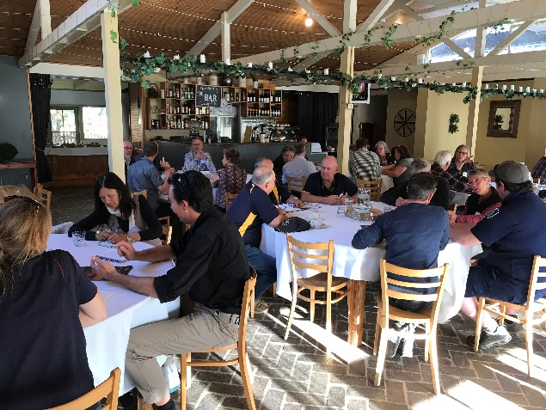
Regional Roundtables are an initiative supported under the Victorian government’s Our Catchments, Our Communities strategy. They involve relevant government agencies and authorities, local government, Traditional Owners, Landcare and other community groups getting together to discuss what’s important in NRM across the region.
The 2018-19 Regional Roundtables were held in:
- Boort, 26 February 2019
- St Arnaud, 5 March 2019
- Epsom, 13 March 2019

What did we hear from communities?
Valuable local knowledge and community feedback during the sessions is summarised under four themes:
- Community
  - Support for community groups
  - Continued collaboration between agencies across the region
  - Strengthen community engagement
- Waterways, wetlands and floodplains
  - Increased access (disability, angling and passive recreational access)
  - Recreational benefits from delivery of water for the environment
  - Carp eradication
  - Crown frontage management
  - Richardson River management actions
  - Waterway and wetland restoration
- Biodiversity
  - Improve weed awareness, capacity building and compliance
  - Native Vegetation regulation and enforcement
  - Weed resistance to Glyphosate
  - Captive breeding/release programs
  - Roadside vegetation management
  - Forest management strategies
- Land and soils
  - Absentee landholders
  - Sustainable agricultural extension
  - Climate change readiness
  - Supporting innovative farmers
  - Stewardship
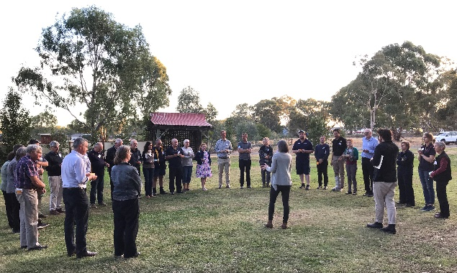Progress against the identified themes and community feedback, including what’s been or being done, is summarised on the back page.
More information can also be found at http://www.nccma.vic.gov.au/regional-catchment-strategy#node-1676
Community feedback | Boort | St Arnaud | Epsom | What can we do about it?
Theme: Community
Establishment of a youth environmental council to better engage young people in environmental projects. |  |  |  | - Agriculture Victoria is taking a lead on engaging youth on policy and environment action through the Weeds & Rabbits Project (Youth engagement in established invasive species management). More information can be found at https://weedsandrabbits.com/projects/  - The Department of Environment, Land, Water & Planning (DELWP) are currently developing a Landcare Youth Engagement Plan to better engage and attract young people into the Victorian Landcare Program.  - An inaugural North Central Intrepid Landcare Retreat will be held in August 2019 to form a network of 18-35 year-olds interested in environmental management.
Increased visibility of, and participation in Landcare, with a focus on youth engagement.
Support for grant writing skills and increased visibility of funding opportunities |  |  |  | - Grant writing workshops (inc. iMap training) are frequently delivered in the North Central region by the Regional Landcare Coordinator. The most recent series of three grant writing workshops were held in April-May 2019.  - Local Government also deliver grant writing workshops, please contact your local Council for more information.
- Grants Victoria at https://www.vic.gov.au/grants lists all Victorian Government grant opportunities (open, closed, ongoing and upcoming). Available grants and programs can be filtered by topic (e.g. Environment, Communities) and their relevance to business, government, individual or not-for-profit groups. Visit Grants Victoria for current opportunities.
- GrantConnect at https://www.grants.gov.au/ lists future, current and awarded Australian Government grant opportunities.
- Fund Seeker at Philanthropy Australia’s https://www.philanthropy.org.au/seek-funding/ is your first step if seeking philanthropic funds. Others sources of philanthropic funds in the North Central region include the Wettenhall Environment Trust at https://wettenhall.org.au/grants/ or Helen Macpherson Smith Trust at https://hmstrust.org.au/programs/environment/
Education for new landowners about their responsibilities for land management under the Act. |  |  |  | - All new landholders in the City of Greater Bendigo (CoGB), Macedon Ranges or Mount Alexander Shire receive Caring for Country: a sustainable land management guide for rural living in north central Victoria. This resource aims to assist new and existing land managers, particularly those in the rural living zone, to protect the health of their land and the broader environment. Electronic copies of the guide can be found at http://www.nccma.vic.gov.au/publications#node-172 with hard copies available free of charge by contacting the North Central CMA, CoGB, Macedon Ranges or Mount Alexander Shire Council.
Greater awareness of changes to EPA Act that enables community members to play a stronger role in regulation practices. |  |  |  | - The general environmental duty of the Environment Protection Amendment Act 2018 (the Amendment Act) will come into force in July 2020 and requires “a person who is engaging in an activity that may give rise to risks of harm to human health or the environment from pollution or waste must minimize those risks, so far as reasonably practicable”. The general environmental duty will be supported by the introduction of numerous tools EPA can use to provide guidance and support for compliance. For more information visit https://www.epa.vic.gov.au/
Extension initiatives regarding sustainable agriculture practices. |  |  |  | - The Regional Agriculture Landcare Facilitator (RALF) provides support services to increase the uptake of sustainable agricultural practices and build stronger networks and partnerships to benefit farmers, community groups and agricultural industries. The RALF is available to support groups or individuals in sourcing relevant agricultural information, identify appropriate funding options or connect them with groups, individuals or Industries to assist with enquires. To connect with your Regional Agriculture Landcare Facilitator please contact the North Central CMA on 5448 7124.
 |  |  |  | - For Agriculture Victoria updates on Dry Season Support visit http://agriculture.vic.gov.au/agriculture/farm-management/drought/dry-seasons-support
Theme: Wetlands, Waterways and Floodplains
Development of a community led Richardson River urban reinvigoration plan for Donald. |  |  |  | - The North Central CMA and Buloke Shire have received funding through DELWP Integrated Water Forums to undertake a scoping study in conjunction with the Donald community to work out a long-term plan for the Richardson River in Donald.
Restoration of riparian zones along the Avoca River. |  |  |  | - The North Central CMA will consider an Avoca River restoration program as one of several options for the next funding cycle (due in July 2020).
Restoration of riffles and ponds in Bendigo Creek. |  |  |  | - Reimagining Bendigo Creek project is currently setting a long-term vision for the Bendigo Creek in Bendigo. This process led by the City of Greater Bendigo and supported by Dja Dja Wurrung, North Central CMA and other partners organisations. Refer to https://www.bendigo.vic.gov.au/Services/Strategic-Planning/Strategic-Planning-Projects/Reimagining-Bendigo-Creek-Plan
Review water management in the Avoca/Avon-Richardson catchment to better support multiple uses (e.g. recreational, social, environmental and production) |  |  |  | - The North Central CMA are willing to work with the community to seek funding to scope this project idea further. Any progress will require strong support from Partner organisations including Water Corporations and Local Government.
Theme: Biodiversity (inc. Pest Plants & Animals)
Provision of Traditional Owner training in the suitable use of fire in fostering grassy open woodlands. |  |  |  | - North Central CMA is running training grants, for Traditional Owners, as part of an Australian Government Plains for Wanderers project.
Updating the status of State prohibited weeds in Victoria. |  |  |  | - Declared noxious weeds under the Catchment and Land Protection Act 1994 are reviewed periodically with the last update on 20 July 2017 see http://agriculture.vic.gov.au/agriculture/pests-diseases-and-weeds/protecting-victoria/legislation-policy-and-permits/declared-noxious-weeds-and-pest-animals-in-victoria
 |  |  |  | - Agriculture Victoria aims to prevent the introduction of State prohibited weeds into Victoria and to detect and eradicate any infestations before they become widespread. To help protect Victoria from these high-risk invasive plants, community, industry and government agencies can look out for and report State prohibited weeds by emailing weed.spotters@ecodev.vic.gov.au or calling 136 186. For more information on the current list of State prohibited weeds visit http://agriculture.vic.gov.au/agriculture/pests-diseases-and-weeds/weeds/state-prohibited-weeds
 |  |  |  | - In April 2018, the Arthur Rylah Institute for Environmental Research updated the Advisory list of environmental weeds in Victoria. This report ranks environmental weed species with respect to management urgency and is intended to provide regularly updated, ‘non-statutory’ advice to Victorian conservation managers. As such, feedback about the impacts of weeds in different ecosystems is welcomed and valued. To view the report visit https://www.ari.vic.gov.au/__data/assets/pdf_file/0027/125919/ARI-Technical-Report-287-Advisory-list-of-environmental-weeds-in-Victoria.pdf
Dja Dja Wurrung involvement in reestablishment of indigenous food and fire plants.
Theme: Land and Soils
Explore ways to offer additional support and project ideas to Landcare groups operating around Boort. This could include the facilitation of new relationships with other regions, or support in conducting community Landcare events in order to generate fresh energy from new membership and ideas, or encouragement of digital technologies that could uncover new research ideas or other community groups in the region. |  |  |  | - The Loddon Plains Landcare Network (LPLN) is comprised of 17 groups on the Loddon Plains including the Boort district. In 2017/18, the LPLN acquired 19 tablets through Victorian Landcare Grant funding through an “Engaged, Connected, Tech Savvy and On-ground Ready” project. This project utilised the network’s combined resources to develop member skills and knowledge, increase their understanding and usage of technology and enable member groups to be project ready using modern technology to plan, track, map and monitor their projects. To get in contact with the LPLN or find more information on current events and projects, visit http://www.lpln.org/
Sustainable farming extension programs that focus on carbon sequestration, minimum tillage, regenerative agriculture, etc, potentially through ongoing demonstration sites. |  |  |  | - The North Central CMA recently secured Australian Government funding for a Regenerative Agriculture project to work with six landholder groups over a five-year period. Regenerative Agriculture Community Groups currently engaged for three years include Normanville, Raywood and Upper Loddon & Avoca (with Mt Alexander district commencing in 2019-20). For more information on the Regenerative Agriculture project visit http://www.nccma.vic.gov.au/projects/agriculture#node-2041
 |  |  |  | - For Agriculture Victoria updates on Dry Season Support visit http://agriculture.vic.gov.au/agriculture/farm-management/drought/dry-seasons-support
- Online extension resources for communities of practice can also be found at:
  - Extension Aus https://extensionaus.com.au/
  - Grains Research & Development Corporation (GRDC) https://communities.grdc.com.au/
- Grower groups in the North Central region include:
  - Birchip Cropping Group https://www.bcg.org.au/
  - Victorian No-Till Farmer Association https://www.vicnotill.com.au/
More resources for farmer driven skill/knowledge sharing and support groups. |  |  |  | - The Australian Government has allocated $134 million under Smart Farms to support the development and uptake of best practice, tools and technologies that help farmers, fishers, foresters and regional communities improve the protection, resilience and productive capacity of our soils, water and vegetation, in turn supporting successful primary industries and regional communities. The Smart Farms program, supported by your Regional Agriculture Landcare Facilitator, runs over six years from 2017-18 and is made up of three elements:  - Smart Farming Partnerships  - Smart Farms Small Grants  - Building Landcare Community and Capacity  - To find out more about current grant opportunities visit http://www.agriculture.gov.au/ag-farm-food/natural-resources/landcare/national-landcare-program/australian-government-investment-in-landcare
More widespread use of soil moisture probes, and increased access to broader scale databases for comparative purposes. |  |  |  | - Agriculture Victoria are investigating a Victorian online platform to incorporate soil moisture information for public use.
- For soil moisture probe and weather data near you visit:
  - iNTELLiWeb http://intelliweb.mait.com.au/ (username = dpi and password = dpi)
  - Data Farmer https://www.datafarmer.com.au/

Please contact the North Central CMA on 5448 7124 or email info@nccma.vic.gov.au

