Application Kit
for a
levee maintenance permit

Authorising Access to and Maintenance of
Existing Crown Land Levees

10 November 2016

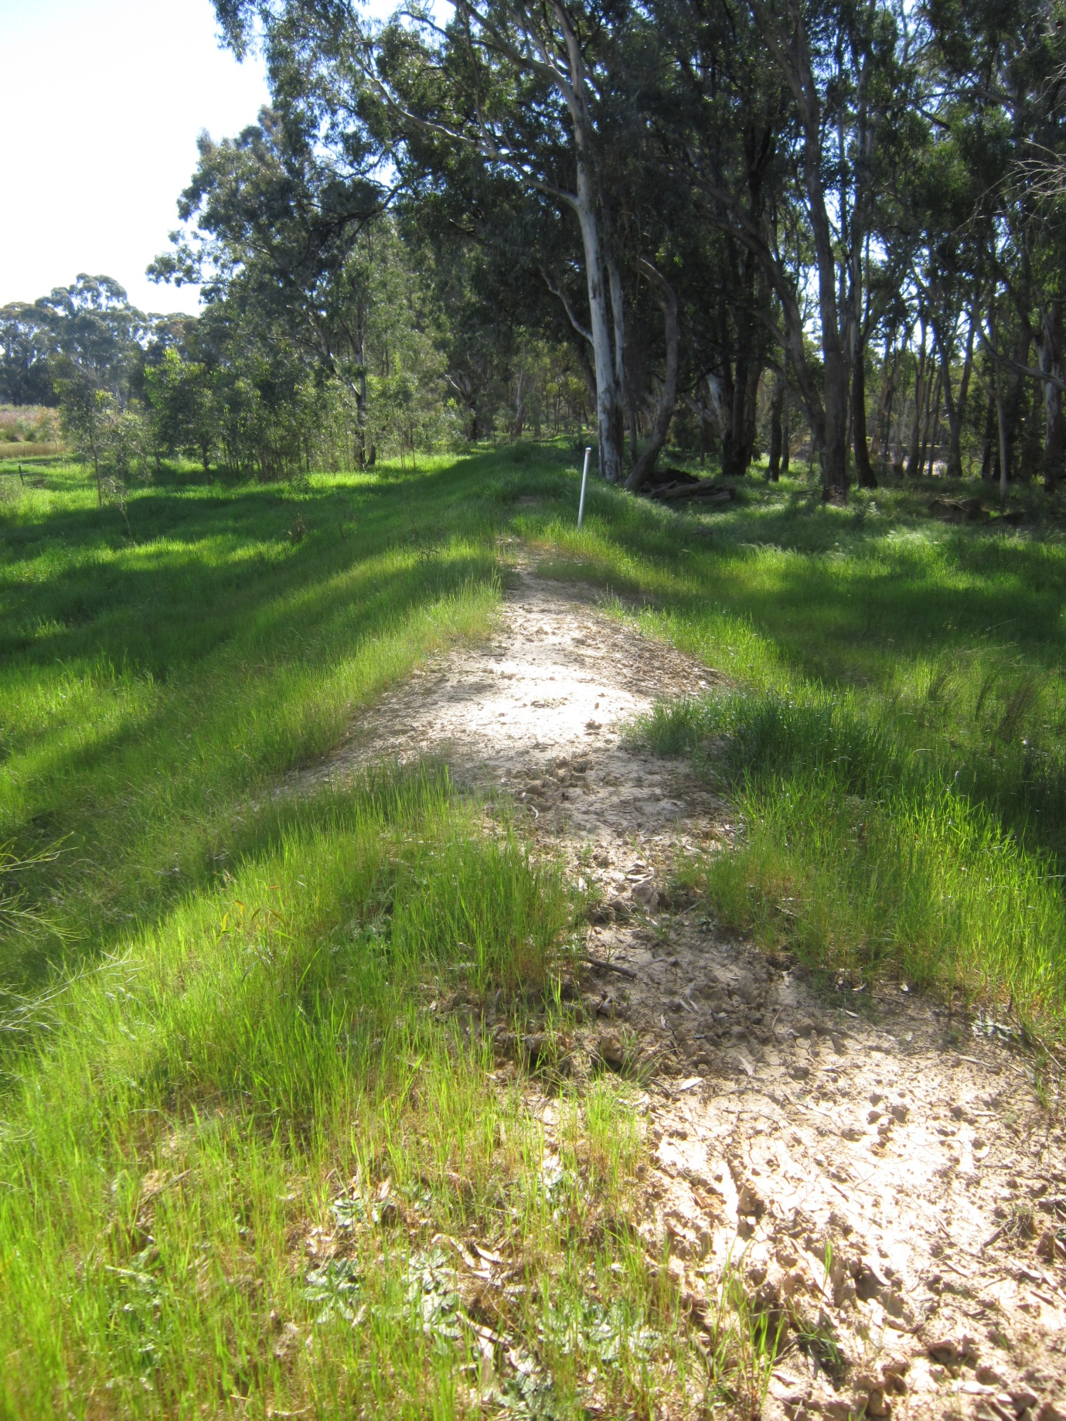

INDEX

INDEX 3
INTRODUCTION 4
Step 1 – Applicant’s check List 5
Step 2 – Understanding the Permit Scheme 6
Step 3 – Getting information – Pre-Application Inquiry 8
Step 4 - Other approvals that may be required before you can start 9
Step 5 – Reassess whether Crown land Levee Maintenance is for you 11
Step 6 – Permit Application 12
Step 7 – Map and significant local features 12
Step 8 – Work Plan 13
Step 9 - Lessee Approval 15
Step 10 - Varying your permit 15
Definitions 16
Contact List 17
FORMS 18
Pre-Application Inquiry Form 19
Application Form 20
Permit Variation Application Form 24

INTRODUCTION

This Application Kit has been prepared to help you understand what a levee maintenance permit is for and how to get one.
The levee maintenance permit scheme is set out in the Water Act 1989 and the permits are issued by Catchment Management Authorities (CMA) as delegates of the Minister.
A levee maintenance permit can be issued to anyone who wishes to maintain a levee located on Crown land so long as they have made an application that is consistent with the Act and that application is approved by the CMA.
A levee maintenance permit can authorise the person who holds it to:
- access a Crown land levee, including passing over Crown land
- remove specified trees and plants from the levee
- restore heavily eroded sections of the levee, and
- undertake minor maintenance of the levee for up to five years.
The permit can authorise these activities across different Crown land tenures including National Parks, State Forests and Crown Land Reserves, subject to conditions.
A levee maintenance permit does have limitations, however. It cannot authorise:
- the building of a new levee or the moving of a levee
- you to make the levee bigger than it originally was
- maintenance of a levee on private land, nor
- the use of someone’s private land get access to the Crown land levee.
At the back of this Kit are the forms you need to use to apply for the permit. The process starts with you lodging a Pre-Application Inquiry Form, which will start the conversation between you and the CMA about when you want to do and when you want to do it.
Also included in this Kit are checklists that you can use when you make an application, so that you can be confident that you have provided all the documentation required.
A levee maintenance permit does not exist in isolation, however, as Crown land is used for many different purposes and has many laws that apply to it. This Kit will help you understand when those laws might apply to you and how to undertake your activities to minimise your chances of triggering other permit requirements. Sometimes - depending on the nature of the land - this is unavoidable and your proposed maintenance activities may become expensive for you to undertake. As a consequence, when applying for a Crown land levee maintenance permit you should also consider other ways to protect your assets from flood risk as these may be more cost effective for you. Other options include raising the floor levels of buildings or creating smaller ‘curtilage’ levees around specific infrastructure. The CMA can discuss these options with you.

Step 1 – Applicant’s check List

The checklists below are to assist you in making your permit application.
The first list covers the Pre-Application process, which is designed to assist you to seek information from government that you need to make a permit application.
The second list covers those things you need to attach to your Application to ensure that you have completed all the necessary paperwork.
Each of these elements are covered in the following pages and the necessary forms are included at the back of this Kit.

Pre-Application
Before making your levee maintenance permit Application did you lodge a Pre-Application Inquiry Form with the CMA to and did you find out if:
- the land is eligible for a permit , and
- there were any leases over the land?
Did you meet with your CMA (preferably at the levee) to discuss if there were any features of the Crown land that may require additional permits, such as:
- any known cultural heritage, or
- any known threatened plants?

Application
Before submitting your Application, have you attached:
- an Application Form
- a map of the levee system with significant features marked
- a Work Plan for maintenance activities
- Proof of public liability insurance
- signed approval of relevant Crown land lessees (if applicable)
- a Cultural Heritage Assessment (and Management Plan, if applicable)
- the location of any threatened flora and fauna communities within the vicinity (if applicable)?

Permit Execution
- Is my permit still valid (check dates)?
- Have I notified the CMA of my intention to start activities?
- If I am using machinery, am I doing so in accordance with the regulatory requirements, e.g. Forest (Fire Protection) Regulations 1958 if I am in a State forest, National, State or Regional Park or on protected public land, and the Country Fire Authority rules for other land?
- Did I complete all earth and machinery works in the first year?
- Did I notify the CMA that I have finished major works?

Step 2 – Understanding the Permit Scheme

What the permit is for
As explained in the introduction to this Application Kit, a levee maintenance permit gives the permit holder the right to access specified Crown land and to maintain a specified levee on that land.

What is a Levee and what is Maintenance
A levee is a mound or bank constructed primarily of earth, stone or gravel, the purpose of which is to obstruct or deflect the flow or water. Maintenance may include reconstruction of part of that levee. Crown land structures that were built for a purposes other than obstructing or deflecting the flow of water cannot be maintained under this permit scheme.

Maximum Dimensions of the Levee
When you make an Application you must specify the dimensions (that is the height and width of the levee) that you wish to maintain the levee to. Discuss this with your CMA.

Length of levee Maintainable
A single permit may authorise the maintenance of a span of levee even where that span of levee is interrupted by land for which a permit cannot be issued (such as private land).

Who can be issued a permit
A permit can be issued to any legal person (including an individual, group of named individuals or a legal entity such as a corporation) that makes an Application in accordance with the Act. The CMA has full discretion, however, to decline to issue a permit. One reason the CMA may decline a permit is where the levee is already being maintained under a permit or by a Government agency.

Period of the permit
A permit may be issued for up to five years. The permit can only authorise the use of machinery (i.e. trucks) and the introduction of soil or other material to the Crown land within the first 12 months of the period of the permit. You must complete these ‘major maintenance’ activities within the first twelve months otherwise you will be required to apply for a new permit.

Private Land Neighbours
A permit cannot authorise the maintenance of those sections of a levee that are located on private land; nor can the permit authorise access over private land to a Crown land levee. If you wish to maintain a levee (or a section of levee) that is located on private-land you must discuss and make arrangements with the private-land owner. Also note that any private-land activities may be subject to the Planning Scheme overseen by the local Council. In any event, it is advisable that you talk about your intentions to maintain a Crown land levee with neighbours of that levee so that you ensure that you do not trespass on private land when exercising your permit.

Refusing a permit
A range of different factors are taken into account when deciding whether to issue a permit. The decision not to issue a permit is at the discretion of the CMA.

Offences relating to unauthorised activities and cost of restitution
If you carry out maintenance without a permit, breach your permit condition or exceed the levee dimensions approved under the permit, you can be found guilty of an offence. Heavy penalties apply in relation to unauthorised activities on Crown land levees (up to $17,000 or one year in prison). In addition, you can also be held liable for the costs of rectifying damage to the Crown land, including to the levee. You should talk with the CMA before you make your permit application to help ensure that your permit covers everything you want to do.

Insurance
You must have public liability insurance with a minimum sum insured of $10,000,000 to cover any risks arising from your activities associated with maintaining a levee on Crown land. A copy of the relevant certificate of currency should be provided with the completed application form.

Hazards and Utilities
It is your responsibility to be aware of all hazards on the site upon which the levee is located. These might include, but are not limited to, overhead powerlines, underground cables, pipes, dangerous trees, mine shafts etc. Your work plans should identify all hazards and how you will ensure the safety of you and anyone acting on your behalf, as well as any other park users from those hazards.

Fire Controls and the Use of Machinery
All activities undertaken under a levee maintenance permit, including the use of machinery, are subject to the fire prevention provisions Country Fire Authority Act 1958 and associated regulations.
Information on your obligations under that Act can be found at
http://www.cfa.vic.gov.au/fm_files/attachments/warnings_and_restrictions/cfa_can_I_cant_I_brochure.pdf
and at http://www.depi.vic.gov.au/fire-and-emergencies/public-land-fire-restrictions
If you wish to maintain a levee located in a in a State forest, National, State or Regional Park or on protected public land, fire restrictions are in force all year round, reflecting the highly flammable nature of those environments. For other land fire danger periods are declared by the Country Fire Authority by municipality during periods of increased fire risk.
To understand your obligations on all land you can contact your local DEWLP and Parks Victoria offices for advice. A list of fire restrictions in force can be found at:
http://www.cfa.vic.gov.au/warnings-restrictions/fire-restrictions-map/
Please note, that these provisions sometimes apply to neighbours of Crown land estates, so the use of machinery on your private land may similarly be affected.

Step 3 – Getting information – Pre-Application Inquiry

Pre-Application Process
The purpose of the Pre-Application phase is to facilitate the exchange information between you, the applicant, and the relevant government agencies. This will achieve two objectives.

The first is to ensure that you have the information essential in applying for your permit. Following the lodgement of a Pre Application Inquiry Form (attached) the CMA will be able to advise you if:

    - the land on which the levee is located is covered under the permit Scheme (some sections of Crown land - and all private land - is excluded from the permit scheme)
    - there are any leases over the land (you need the approval of lease holders prior to being issued with a permit)
    - they are aware of any environmental or cultural issues which will require you to either seek approval under a different legal framework and which may need to be addressed in your Work Plan.
Some of that information – such as the location of cultural heritage or threatened communities of flora - may result in you having to think about maintaining the levee another way. These discussions are designed to reduce any potential delays in the permit application phase, thus saving you time and money in the long run.

The Pre Application Inquiry Form is also an opportunity for you to flag with the CMA the dimensions to which you wish to maintain the levee. The CMA can consider those dimensions and advise you if they are likely to be approved before you make your Application and thus before you go to the trouble of preparing your Work Plan. The CMA may also advise you of any known safety issues, such as whether the levee is on the river bank and is being undercut by the river, which may render the levee unmaintainable.

The CMA may meet with you - preferably on site - to discuss your proposal with you. This meeting will give you the opportunity to explain the dimensions to which you wish to maintain the levee and your proposed access routes.
As a result of these preliminary discussions, all parties should have a common understanding of your intentions.

Step 4 - Other approvals that may be required before you can start

Overview
Crown land is managed to protect a variety of values and some of these values are protected by legislation: both state and Commonwealth. As a result, even though we aim to make the levee maintenance process as simple as possible, you may need more than the approval of the CMA before you can proceed to undertake you levee maintenance activities. For example, it is possible that you may also require approval under laws covering:
- cultural heritage
- environment protection, and
- Native Title.
The CMA cannot make the authorisations necessary under these laws, as they are administered under different acts of parliament by different government agencies and entities. However, the CMA can assist you by directing you to the appropriate agency and may – where the approving agency is DELWP - lodge the necessary permit applications for you.
Please be aware, however, that it remains the responsibility of the permit holder to ensure they have all the necessary approvals before they conduct their maintenance activities.

Cultural Heritage
Victoria’s cultural heritage is a valuable asset and can date back thousands of years. All Crown land within 200 metres of a river is assumed to have cultural heritage and it is the applicant’s obligation to undertake maintenance in a way that protects it, including stopping work if unknown cultural heritage is discovered during activities. Work in areas where cultural heritage is discovered may be able to recommence (subject to a management plan) once it has been assessed by a Cultural Heritage Officer. You can protect cultural heritage and avoid needing a permit in many situations by not digging on Crown land and not allowing machinery or equipment to cut into the soil, especially by avoiding driving over wet soil. For more information, see: http://www.dpc.vic.gov.au/index.php/aboriginal-affairs/heritage-tools/aboriginal-cultural-heritage-register-and-information-system

State Environmental Laws - vegetation and wildlife
The removal of vegetation from a levee or to enable you to “pass over land” to access that levee can be authorised under this permit. For this reason, it is very important that your permit application clearly identifies any vegetation you wish to remove. In some instances, the removal of vegetation may also require a permit from DELWP in order to comply with the Flora and Fauna Guarantee Act and, if approved, that permit will be issued to you in conjunction with your levee maintenance permit. Please note that the removal of vegetation will not require a permit under the Planning Scheme where the Crown land is managed by or on behalf of the Secretary of DELWP.
If you have requested approval to remove vegetation in an area of high ecological value, you may trigger Commonwealth environment protection legislation (see below). For this reason, it is in your interests to restrict access to the levee via either existing tracks or across private land (with the approval of the private land owner).
It is illegal to move or relocate wildlife without a permit issued under the Wildlife Act 1975. If it is likely that wildlife may need to be moved in order to maintain a levee (e.g. removal of trees with hollows or the digging of land in which there are wombat or lizard burrows) a suitably qualified person will need to obtain the necessary permit. The CMA can provide advice to you on this and for more information visit: //www.depi.vic.gov.au/environment-and-wildlife/forms-for-wildlife-national-parks-and-the-flora-and-fauna-guarantee-act.

Commonwealth Environmental Laws
A levee maintenance permit will not exempt you from the application of Commonwealth laws. The Environment Protection and Biodiversity Conservation Act 1999 (EPBC Act) is the Australian Government’s central piece of environmental legislation. It provides a legal framework to protect and manage nationally and internationally important flora, fauna, ecological communities and heritage places, which are defined in the Act as matters of national environmental significance.

Levees will be largely unaffected by these laws, as they are existing structures, however, access routes to the levee may trigger environmental assessments. For this reason, it is advisable to stick to existing tracks as far as possible, or use your own private land to access the levee.

For more information on protected areas visit: http://www.environment.gov.au/topics/about-us/legislation/environment-protection-and-biodiversity-conservation-act-1999/protected
Or visit: http://www.environment.gov.au/topics/about-us/legislation/environment-protection-and-biodiversity-conservation-act-1999

Native Title
Native Title Holders have rights over some Crown land and before levee maintenance activities can commence, the relevant registered aboriginal parties may need to be consulted. The CMA can direct you to the appropriate people to discuss this process. In most cases, levees that existed prior to 1996 and which were built with the government’s authorisation, will have extinguished native title.
See
http://www.dpc.vic.gov.au/index.php/aboriginal-affairs/publications-and-research/aboriginal-cultural-heritage-mini-poster-series

Planning Scheme
Maintenance of levees on Crown land does not require a permit under the Planning Scheme where they have been authorised under this (Water Act 1989) levee maintenance permit scheme.

Step 5 – Reassess whether Crown land Levee Maintenance is for you
After you have met with the CMA to discuss your proposal, and once your Pre-Application Inquiry Form has been returned to you, re-assess whether maintaining a Crown land levee is the best way to manage your flood risk. You may like to review the other options available to you and compare the ongoing cost of these options against the ongoing cost of maintaining a Crown land levee. Other options include raising the floor levels of buildings or creating smaller ‘curtilage’ levees around specific infrastructure, which the CMA can discuss with you.
The kinds of expenses that may be incurred in maintaining a Crown land levee include:
- costs of works – equipment, soil, contractors, arborists
- insurance
- engineering reports – if there are issues determining the height of the levee
- cultural heritage assessment – initial assessment may cost a few hundred dollars, for a large area, an assessment can cost thousands
- cost of ensuring the site is safe
- the cost of the CMA’s application fee
- engagement of an Arborist for tree removal
- working around utilities – Water Authority pipes/Telstra cable/overhead and underground electricity/sewerage systems etc.
This is not to discourage you from making a levee maintenance permit application, only to remind you that in some circumstances - after receiving information based on your initial inquiry - you may decide it is more effective to manage your flood risk another way.

Step 6 – Permit Application

Name on the Permit
When completing the Application Form, please consider that:
- a “legal person” must make the application, either as an individual, group of individuals (individually named) or as a legal entity such as a corporation
- the name of the permit will need to be in the same name as the person who holds public liability insurance.
Only the person named on the permit is entitled to carry out or contract out the activities authorised by the permit. Any labour, machinery or materials bought onto the Crown land for the purposes of implementing the permit must be supervised by the permit holder. The permit holder must have in their possession a copy of their permit and proof of their identity at all times when undertaking maintenance activities.

Map of the area
You will need to attach an annotated map of the levee you wish to maintain – see “Step 7” below.

Work Plan
You will need to attach a Work Plan to your permit application which describes what you intend to do on the levee and how you intend to manage those activities – see “Step 8” below.

Crown Land Managers Conditions
As part of the permit process, both the CMA and the Crown land manager can put conditions on your permit. The CMA will coordinate the permit conditions for you.

Step 7 – Map of proposed activities and significant local features

Your Application Form must be accompanied by a map of the levee that you proposed to maintain. The map must clearly mark:
- the section of levee you wish to maintain
- the route you intend to use to access the levee
- the site you propose storing machinery and materials during the initial maintenance phase
- the location of any machinery turning circles
- the vegetation you intend to remove
- trees of cultural or environmental significance that will not be removed
- the proposed site for the distribution of felled and lopped tree and other organic waste
- the site of any protected flora you intend to re-locate during maintenance activities (if protected flora has been identified)
- the location of existing features such as waterways, buildings, power-lines, roads, access tracks, fences, channels, drains, pipelines, cables, water storages and other similar features that are in proximity to the levee
- the location of any borrow pits (note, borrow pits will not be authorised on Crown land).

Step 8 – Work Plan

It will be a condition of your levee maintenance permit that you conduct your maintenance in accordance with an approved Work Plan. Your Work Plan must describe what you intend to do and how you intend to do it, as well as setting out how you will protect public safety, aesthetic and archaeological values as well as the environmental and water resource values of the waterway, riparian and riverine environment during the maintenance of the levee.
Please note that endorsement of the Works Plan does not transfer any risks or obligations associated for the management and operation of the activities from the permit holder to the CMA.
A template for a standard levee maintenance work plan is available for you to use as part of your application.

Work Plan for Major Maintenance Activities – first year of permit
The permit can only authorise the use of machinery and the introduction of soil or other material to the Crown land within the first 12 months of the period of the permit. So your Work Plan must show how you will complete these ‘major’ maintenance activities within the first twelve months.
For this reason, the Work Plan must set out those activities to be completed in the first year of the permit including:
- all earthworks that are proposed
- the way in which earthworks will avoid damage, erosion or degradation to native vegetation, waterways, aquifers, the riparian environment, the riverine environment or other property
- the types of soil and materials that are proposed to be brought onto the Crown land
- the hours and route of entry
- how access routes will be kept to a minimum and where existing access tracks will be used
- the type of machinery that is proposed to be used
- where machinery will be stored when not in use
- how the site will be kept clear of rubbish and debris at all times
- the removal of debris from Crown land (including any vegetation)
- how interference to the access rights of other Crown land users will be minimised
- what plants will be planted on the levee as part of the rehabilitation of the site, and
- how any access routes will be revegetated, if applicable.

Work Plan for Minor maintenance activities –up to five years.
The permit can include an additional period of up to four years. This enables you to undertake minor maintenance activities, covering such things as the removal of saplings, weeds and rabbit burrows to prevent the levee from falling into disrepair. Your Work Plan must allow for any minor maintenance activities, such as:
- ongoing removal of saplings and shrubs
- ongoing planting, watering and general care of approved grasses and plants on the levee
- ongoing planting, watering and general care of approved plants on revegetation sites
- ongoing removal of rabbit burrows and other non-native species habitats
- how cracks in the levee will be addressed, and
- how wheel ruts and other damage in the levee caused by other Crown land users will be addressed.

(Note that a levee maintenance permit cannot authorise the use of machinery or the introduction of soil or other materials to the land to carry out maintenance after the first 12 months of the permit).

Site Restitution and Clean Up
It is important that cleared sites are quickly revegetated with local plant seeds or stock, to prevent weeds taking advantage of the freshly disturbed site. For this reason, your Work Plan should specify how you will:
- return soil inadvertently disturbed to its original profile and compact and revegetated to prevent erosion
- restore ground surface levels to reflect the topography prior to the levee maintenance activities occurring and compact and revegetate the site with local indigenous species to protect it from erosion, and
- rehabilitate any tracks inadvertently made.

Protecting Crown land values
Where practical the Work Plan should identify how you will:
- avoid or minimise impact on threatened species and communities, or disturbance to native vegetation (unless permitted – see Step 4)
- avoid or minimise the impact on wildlife
- prevent the introduction of weeds and other pests
- minimise interference with the tree canopy over-hanging the levee
- minimise interference with vegetation roots, especially trees, close to the levee and around access routes
- prevent anything used in connection with the maintenance activities from entering into and polluting the waterway, the riparian or riverine environment, and
- restore any vegetation that is disturbed with local indigenous species.

Public Safety
The Work Plan must set out how you will ensure the safety of:
- CMA officers inspecting the maintenance activities
- Crown land managers undertaking land management activities or supervising the maintenance activities
- visitors accessing the Crown land
- the holders of leases over the land
- the holders of licenses over the land
- machinery operators, and
- other people undertaking maintenance activities on behalf of the permit holder.

Crown Land Licence holders
A number of licences may have been issued over the relevant Crown land. For example; cattle grazing, apiculture, pipe line licences and other infrastructure licences. The CMA (upon the advice of the land manager) will notify you where there is a licence over the land for which a permit has been issued (see Pre-Application Form). You should exercise your permit co-operatively with the rights of other licence holders.

Step 9 - Lessee Approval

Before a permit may be issued you must demonstrate that you have the approval of any Crown land lease holders to the maintenance you propose in your application. The lessee must sign your permit Application Form prior to the application being lodged with the CMA.
Please note: the CMA can make inquiries on your behalf about leases over the land, at your request – see Pre-Application Inquiry Form.

Step 10 - Varying your permit

Once you have been issued a permit circumstances may arise where you require a variation to that permit. The attached permit Variation Form can be used to initiate that process. Please note that a variation to a condition on a permit:
- must have consent of a lessee who has a lease over the land on which the levee is located, and
- must have the consent of a lessee over land that is used for access if the variation affects that lease.
The CMA and Crown land manager will both need to consider the variation.
You should also note that the CMA can, within that constraints set out in the Water Act , vary a permit condition.

Definitions
“Act” means the Water Act 1989
“applicant” means the applicant for a levee maintenance permit.
“application” means an application for a levee maintenance permit.
“Crown land” has the same meaning as “Specified Crown Land” in Section 84AAA of the Water Act 1989.
“CMA” includes an employee of a Catchment Management Authority to whom the power to issue levee maintenance permits has been delegated.
“The Department” means the Department under the instruction of the Minister for Environment, Victoria.
“DELWP” means the Department of Environment, Land, Water and Planning.
“land manager” means the Crown land manager of specified Crown land as per s.84AAA of the Water Act 1989 or the person acting as the managers delegate.
“levee” means a mound or bank (whether or not on a waterway) constructed primarily of earth, stone or gravel, the purpose of which is to obstruct or deflect the flow of water over the surface of land.
“span of levee” is that stretch of levee for which a permit is being sought.
“levee system” means a sequence of levee spans that protect a defined area.
“maintenance”, in relation to a levee, includes reconstruction of part of a levee as per s.84AAA of the Water Act 1989.
“major maintenance” are those activities that must take place within the first twelve months of the period of the permit as per s.84AAB(2) .
“minor maintenance” are those activities that can be authorised to take place for up to five years.
“permit” means “levee maintenance permit” and has the same meaning as in Section 3 of the Water Act 1989.
“permit holder” means a person who has been issued a levee maintenance permit.
“Toe of the levee” will be marked on the approved map attached to the levee maintenance permit and means the point at which the constructed levee meets the natural ground.
“The land” means the land on which the levee is located.
“variation” of a permit includes, vary a condition, remove a condition or impose a new condition.
“Work Plan” means a plan submitted with the Application and endorsed by the CMA when approving the Application or following variation (amendment) of the permit.

Contact List
The following map shows the jurisdictions of Catchment Management Authorities across Victoria and the table below the contact for that CMA.
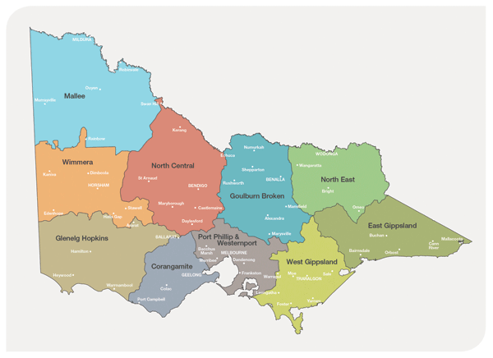
Goulburn Broken CMA  168 Welsford Street  Shepparton VIC 3630  Tel: (03) 5822 7700  reception@gbcma.vic.gov.au | Mallee CMA  DPI Complex,  Cnr Koorlong Ave & Eleventh St, Mildura  Tel: 03 5051 4377 | North Central CMA  628-634 Midland Highway  HUNTLY 3551  Tel: (03) 5448 7124  floodplain@nccma.vic.gov.au | North East CMA  Level 1, 104 Hovell Street, Wodonga VIC 3690  Tel: (02) 6043 7600  necma@necma.vic.gov.au
Corangamite CMA  64 Dennis Street, Colac, Victoria, 3250  Tel: 03 5232 9100  Info@ccma.vic.gov.au | East Gippsland CMA  574 Main Street  Bairnsdale, VIC 3875  Tel: (03) 5152 0600  egcma@egcma.com.au | Wimmera CMA  24 Darlot Street, Horsham, 3400  Tel: (03) 5382 1544  wcma@wcma.vic.gov.au | Glenelg Hopkins CMA  79 French St, Hamilton Vic 3300  Tel (03) 5571 2526  ghcma@ghcma.vic.gov.au
West Gippsland CMA
16 Hotham Street TRARALGON
Tel: (03) 5175 7899
westgippy@wgcma.vic.gov.au

FORMS

Pre-Application Inquiry Form

This is a Pre-Application Inquiry Form for a permit under Part 5AA of the Water Act 1989.

Applicant details:

Name

Postal Address

E-mail

Phone (BH)

Preferred method for response (circle) | Email, Phone or Post

Description of the location of the Levee:

Street Addresses of start and end of levee to be maintained | Street ……………………………….  To Street ……………………………
Attach Map of Levee (if possible)

Types of Maintenance Intended to be undertaken:

A short summary of what you want to do – i.e. use of machinery, soil, tree removal (if any) to help the CMA understand the scale of your proposed activities

Application Form
This Application Form is used to enable people to apply for a Levee Maintenance Permit under Part 5AA of the Water Act 1989.
APPLICANT DETAILS
Company Name (if applicable) | Phone Number

Given name | Surname | Phone Number
(There may be more than one name on the Application)
Postal Address

Email Address
DETAILS OF RELEVANT CATCHMENT MANAGEMENT AUTHORITY
This Application is submitted to:
Catchment Management Authority | Contact name

LEVEE LOCATION
The levee to be maintained is located at:
(describe the location of the levee in terms of both streets and via GPS codes)

SPECIFIED CROWN LAND THE LEVEE IS LOCATED ON
List all Specified Crown land the levee that those portions of the levee to be maintained are located on:
(describe the location of the levee in terms of both streets and via GPS codes)

LEASE HOLDER
The following has a lease over the land and has provided consent to the proposed maintenance activities:
Lease Holder’s Name | Proof that lease holder approval has been granted
 | (e.g. - see attached letter of consent)
LEVEE DIMENSIONS
The dimensions to which the levee is to be maintained are:
 | Dimensions
Height | millimetres/metres
Breadth (footprint) | millimetres/metres
Length | metres/Kilometres
(Speak to your local CMA about your proposed dimensions)
PERIOD THE PERMIT HAS EFFECT

 | Commencement | Conclusion
Major maintenance activities (maximum one year) – use of machinery and brining in of soil | TO BE COMPLETED BY THE CMA | TO BE COMPLETED BY THE CMA
Minor maintenance activities (up to five years from commencement of permit) | TO BE COMPLETED BY THE CMA | TO BE COMPLETED BY THE CMA

DESCRIPTION OF TYPE OF MAINTENANCE ACTIVITIES
Please describe the type of maintenance you propose to undertake eg:
(e.g: topping up levee by 200 mm to restore to pre-eroded height / restoring heavily eroded sections of the levee / removing trees from levee / removing tree roots from levee / re- footing levee) Also describe the earthworks to be undertaken, for example: ‘removal of poorly constructed levee will take place for approximately 200 metres and restored to height of original levee’ ).

You may draw a simple diagram of the proposed activities:

CONDITIONS
To be completed by the CMA and Crown land manager(s) – if any.

The permit holder hereby covenants with the CMA that during the term of the permit, the permit holder will: indemnity the Crown in respect of any claim or liability for property damage and/or injury or death of any person which arises directly or indirectly out of negligence, tort, contract or breach of a statutory duty by the permit holder or any associated party consequential to the use of occupation of the Crown lad, including but without restricting the generality of the foregoing, the pollution or contamination of land or water and any costs charges and expenses incurred in connection therewith.
Signed by the Permit Applicant:

……………………………………………………
Name

……./……/………..
Date

Approval of the CMA Authorising Officer:

……………………………………………………
Name

……………………………………………………
Title

……………………………………………………
CMA

……./……/………..
Date

Permit Variation Application Form
A levee maintenance permit may be varied by either the permit holder or the CMA (note, this can only occur once a permit has been issued).
Permit holder Name and Contact Details

Permit reference number

Description of the Variation Proposed by the permit holder
(please describe the variation to the existing permit you would like to make).

Approval of any lease holder
- over land on which the levee is located
- over land over which access is required by the application

(To be obtained by the Permit Holder)

Comments by the land manager
(if the CMA deems that land manager may be affected by the variation)

(To be obtained by the CMA)

Land manager Contact Details

Comments by the CMA

CMA Contact Details

The permit holder hereby covenants with the CMA that during the term of the permit, the permit holder will: indemnity the Crown in respect of any claim or liability for property damage and/or injury or death of any person which arises directly or indirectly out of negligence, tort, contract or breach of a statutory duty by the permit holder or any associated party consequential to the use of occupation of the Crown land, including but without restricting the generality of the foregoing, the pollution or contamination of land or water and any costs charges and expenses incurred in connection therewith.

Signed by the:
CMA Representative | …………………………………………………………………………………
Date | / /
Permit Holder | …………………………………………………………………………………
Date | / /

(note, the permit holder’s signature is not required when the permit Variation is being proposed by the CMA.

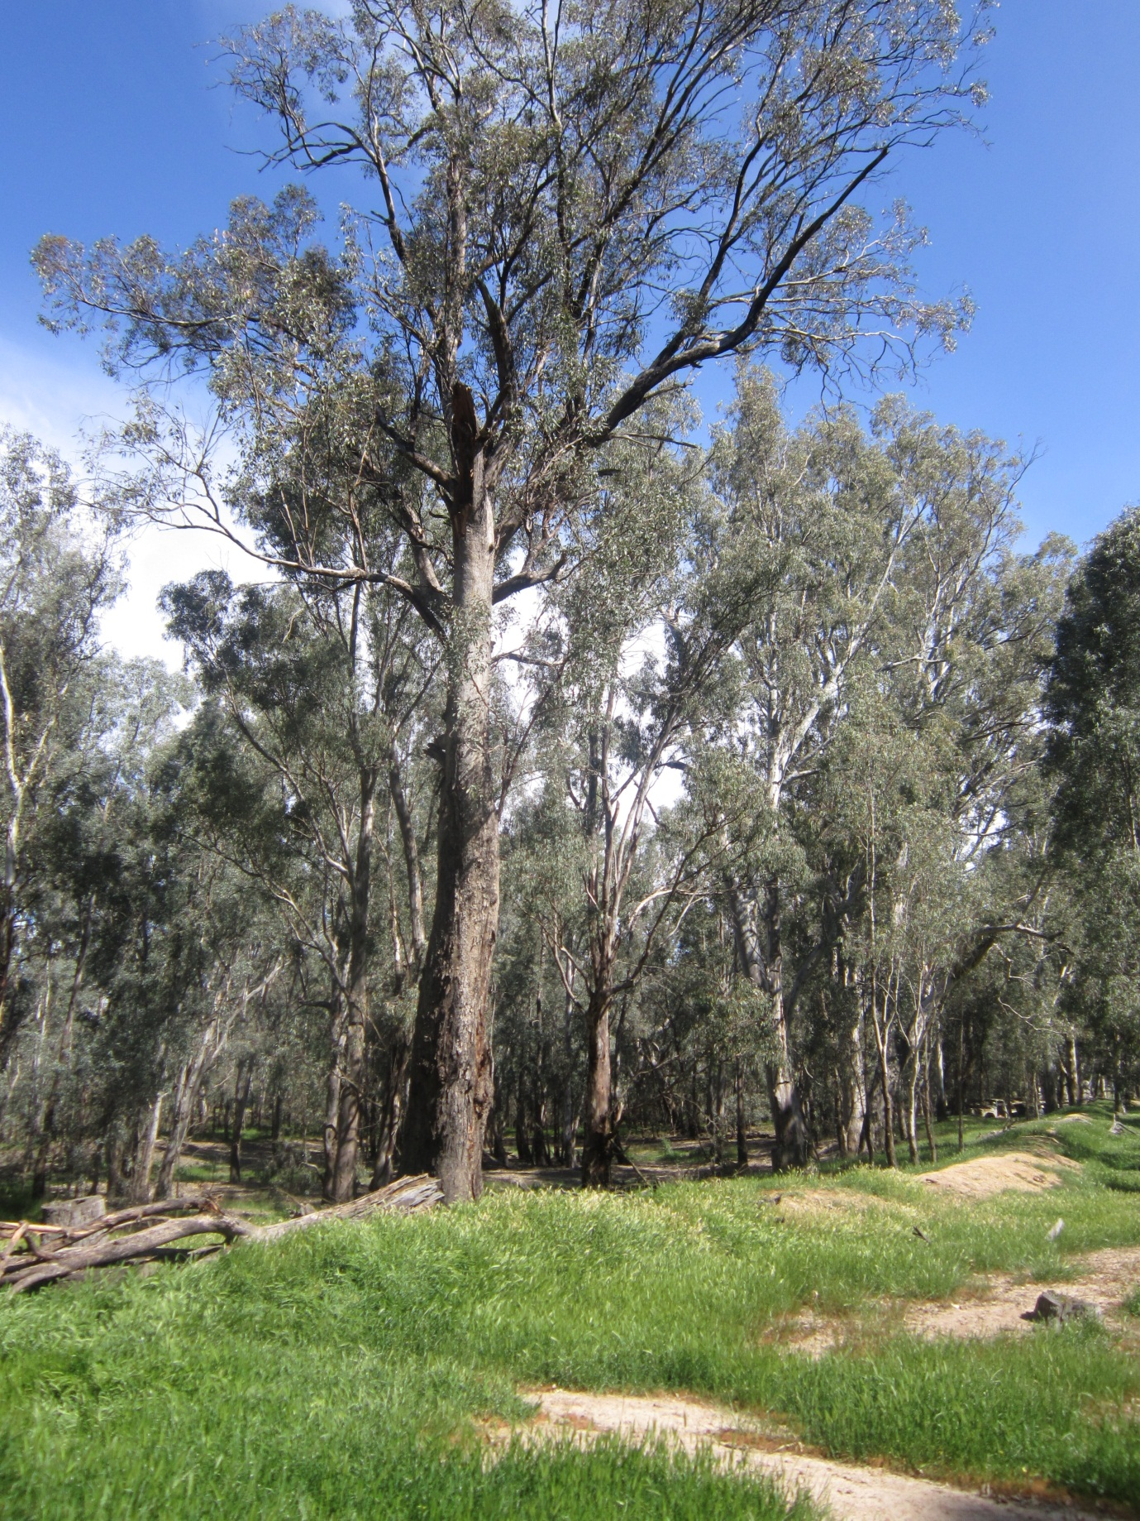

This is expected to migrate to the delwp site shortly. Substitute “delwp” for “depi” in the URL.
If the proposed works are likely to be a matter of national environmental significance the proposal is required to be referred to the project to the Commonwealth Department of Sustainability, Environment, Water, Population and Communities. An Agreement between the Commonwealth of Australia and Victoria means, if a management plan is required, it can be undertaken by DELWP on the Commonwealth’s behalf. The CMA will discuss this with you.
Only vegetation approved under this Permit may be removed, so be precise in your descriptions.
It is illegal to remove produce from Crown land without authorisation. The Crown land manager may put conditions on your permit regarding the removal of vegetation.
A levee maintenance permit does not authorise the use of machinery or the introduction of soil or other material to the land to carry out the maintenance after the first 12 months of the period the permit is in effect
Submitting this Pre-Application Inquiry Form will advise the CMA that you intend to apply for a levee maintenance permit as authorised under the Water Act 1989. Following submission of this Form the CMA will gather information for you on the land upon which the levee is located – including inquiring into any leases over the land - which will assist you in applying for a levee maintenance permit.

