## We’re calling on the local community to help keep a watchful eye on the health of waterways in the upper Coliban catchment

The Upper Coliban is one of the most important catchments in north central Victoria. The area supplies drinking water for more than 130,000 people and is a key asset for the region.

Historical land management practices have resulted in extensive loss of riverside vegetation, which impacts water quality and river health. The Healthy Coliban Catchment project will improve this with fencing, off-stream stock watering, revegetation and weed control.

## We can’t do it alone

Community involvement is vital to the success of the project.

We’re starting a citizen science program to help build people’s knowledge of waterway health.

Training will be provided so participants can collect data that will be used in an annual River

Health Report to demonstrate how restoration works are transforming the catchment.

## We provide training, a test kit and support.

## No experience necessary - it’s easier than you think!

Community members can become citizen scientists by helping monitor water quality

and waterbugs at selected sites.

## Water Quality

* involves monthly testing of temperature, phosphorus, pH, salinity and turbidity
* helps us understand how conditions change over time
* can demonstrate improvements as a result of environmental restoration works
* indicates if water quality is likely to affect the health of fish and other aquatic fauna

## Waterbugs

* are monitored by citizen scientists annually in spring
* are excellent indicators of river health
* can help measure the success of on-ground works we undertake

# If you’re passionate about your local waterways, then we need your help!

## Want to find out more or get involved?

If you live in the project area (map over page) and would like to become a volunteer citizen scientist, please register your interest with the project officer by June 14**.**

[britt.gregory@nccma.vic.gov.au](mailto:britt.gregory@nccma.vic.gov.au) or (03) 5440 1843

*Being a citizen scientist*

*is a great opportunity to volunteer and connect with your community and the environment*

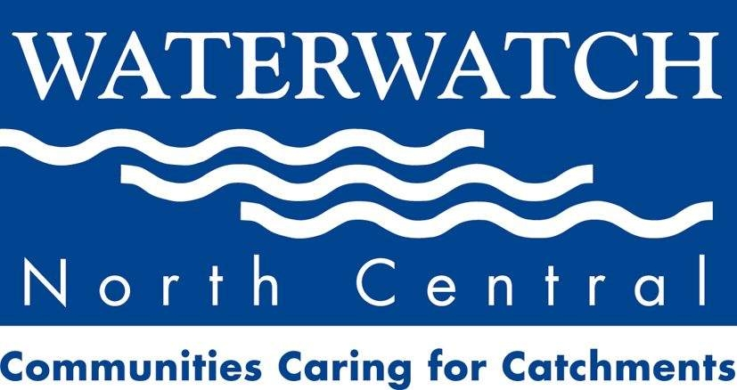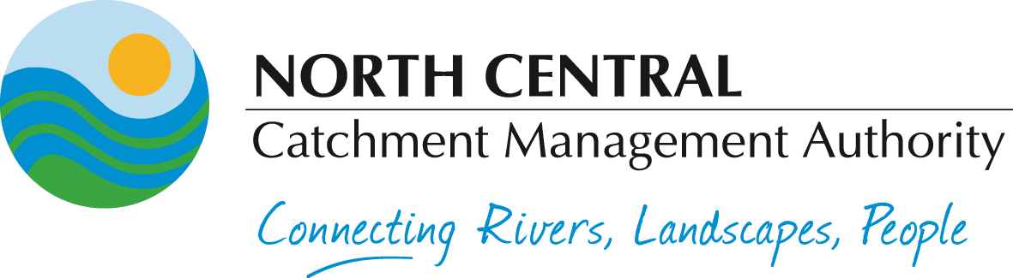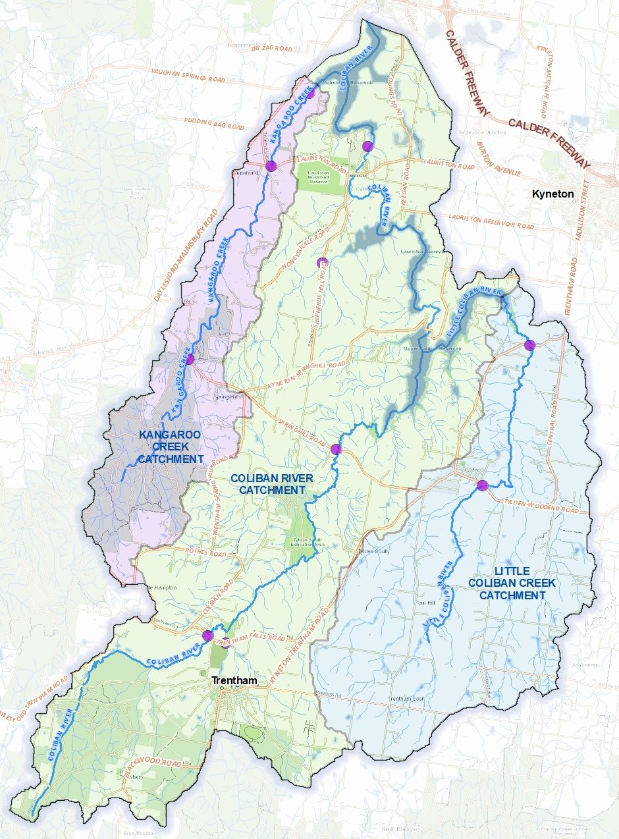

Citizen science monitoring sites*

**RIVER**

# A Healthy Coliban Catchment Project Area

**Upper Coliban Reservoir**

**Lauriston**

**Reservoir**

**Malmsbury**

**Reservoir**

If you live in this area and would like to become involved, please register your interest.

* Other sites may also be considered if they meet the objectives of the project.