Advanced Grazing Masterclass and Farm Visit - Are you grazing to your farms potential?

One day workshop for farmers and land managers to fine tune their grazing management to regenerate their pasture using holistic management principles.

Expression of Interest Form

Places are strictly limited in this one day grazing management short course. The course is open to farmers, land managers and community members located in the North Central Catchment Management Authority area. People from outside the catchment are welcome to apply but priority will be given to those from within the catchment. To submit an expression of interest (EOI), please complete your contact details and the questionnaire below.

Places are available for 15 successful applicants. Course fees are $60 per person (normally valued at $400), which covers:
- One day workshop
- Morning tea, lunch and afternoon tea
- Course notes, guides and planning templates.
- Property visit to set up trial area and pasture identification on your property

Please note that course fees do not include fencing materials, small amount of materials required by participants.

EOIs should be submitted to the North Central CMA by 10 am Friday August 18, 2017 by emailing darren.bain@nccma.vic.gov.au or posting to PO Box 18, Huntly VIC 3551. Successful applicants will be notified by Friday 28 August 2017.

For further information please contact:
Darren Bain, North Central CMA by phone 03 5440 1893 or email darren.bain@nccma.vic.gov.au

Personal Details

Title: _______First Name: ________________________ Surname:___________________________________

Title: _______First Name: ________________________ Surname:___________________________________

Postal Address: ____________________________________________________________________________________________________________________________________________________________________________________
__________________________________________________________________________________________
Phone: __________________________________

Email:_____________________________________________________________________________________

Occupation: _______________________________________________________________________________

Industry: __________________________________________________________________________________

Age: ______________
Expression of Interest Questionnaire
- Current stock numbers and type of stock

- Do you have a vision for you property (where do you see yourself in 10 years’ time?)

- Describe your current farm business or property in terms of enterprises/products, size, years of operation, issues (in less than 100 words).

- What skills are you seeking to learn by undertaking this workshop? Please give an example of how these skills would be applied to your farm business and/or job (in less than 100 words).

- Are you a farmer, land manager or community member in the North Central Catchment? Please place a cross on the area where you farm or work on the map.

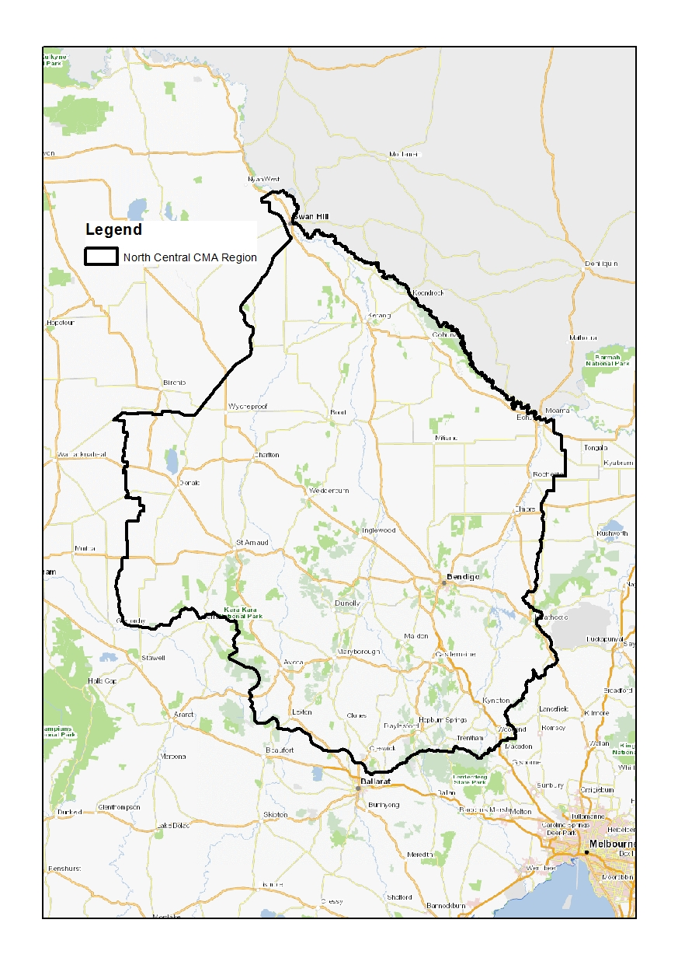
Map of North Central Catchment

- Are you able to provide fencing materials and erect a small enclosure to hold stock for a short period (approx. 50 to 100m fencing)? Yes / No (please circle)
If no please give details:

Acceptance
I can set up a small grazing trial area and I am committed to actively participate in all activities.

Signed: ____________________________ Date: ____________________

