|  |
| --- |
| **FACT SHEET** KERANG RAMSAR WETLANDS |

|  |
| --- |
| kerang Ramsar wetlands protection project |



# PROTECTING THE BEST

# The Kerang Wetlands complex forms an extensive system of over 100 wetlands. It consists of 23 lakes and swamps that cover an area of 9,419 hectares. These wetlands differ widely in permanence, depth, salinity and levels of aquatic vegetation cover.

# The Kerang Wetlands are recognised for their representativeness of Victorian wetlands, flora and fauna values and for the system’s significance as habitat for a large abundance of waterbirds. Their significance is recognised by their listing under the International Ramsar convention.

# ENVIRONMENTAL VALUES

There are 23 Kerang Ramsar listed Wetlands which support large populations of Australian bird species and provide migratory species as well as range of vegetation; over 150 species of Indigenous flora have been recorded with 8 flora species listed as threatened and a further 7 species suspected to be threatened.

There are 23 State-threatened and 18 State near-threatened fauna species. There are six nationally threatened species including the Australian Painted Snipe, Plains-wanderer, Regent Parrot, Murray Cod, Murray hardyhead, and Macquarie Perch. The critically endangered Murray hardyhead is currently found at Round Lake and Woorinen Lake North, outside these locations they have only been identified at two other sites in Victoria

The six wetlands this project has prioritised within the asset area are:

***•Lake Bael Bael*** *(Permanent Open Freshwater Marsh 648 ha****)***

***•Avoca Marshes*** *(Deep Freshwater Marsh 1962 ha)*

* ***Lake Kelly*** *(Permanent Saline 192 ha)*
* ***Lake William*** *(Semi-Permanent Saline 96 ha)*
* ***•Lake Tutchewop*** *(Permanent Saline 752 ha*
* ***•Reedy Lakes*** *(Permanent Open Freshwater Marsh 1962 ha).*

# SOCIAL & ECONOMICAL VALUES

# The public land of the Kerang Wetlands area is a very valuable resource for recreation, land and water based activities. This landscape is valued for recreation, in part from natural ecological assets, such as flora and fauna, but also from the reliable supply of fresh water which has been brought into the area for irrigation purposes. Popular activities include bush walking, sightseeing, camping, picnicking, swimming, sailing, water skiing, boating, fishing and nature study/appreciation.

Eight of the wetlands are Water Supply Reserves and three are Salinity Reserves providing significant economic benefits for irrigation and farming. They also provide an economic benefit to the region through tourism with many people visiting annually during the holiday season.

*“The project has shown highly positive results, the pest plant and animal controls that the project delivered, in conjunction with GMW’s own pest plant and animal programs have highlighted a noticeable visual difference in the landscape and attracted positive feedback from surrounding landholders on numerous occasions.”*

*Russell Durie, Goulburn-Murray Water*

# PROJECT ACTIVITIES COMPLETED:

• Strategic weed control completed at over **240 ha** on Weeds of National Significance (WoNS) and those impacting on the ecological character of the Ramsar sites

• Rabbit baiting to reduce grazing pressure on over **60 ha** of wetland areas.

• Fox baiting on over **2,450 ha** to reduce impacts on native fauna.

• **4.6 km** of fencing has been completed to exclude rabbit grazing.

* **28 ha** of revegetation to improve wetland values.
* Community education and engagement activities that have engaged over **270 people** including events such as the Welcoming the waders, tree planting days with schools and rabbit roadshows.

[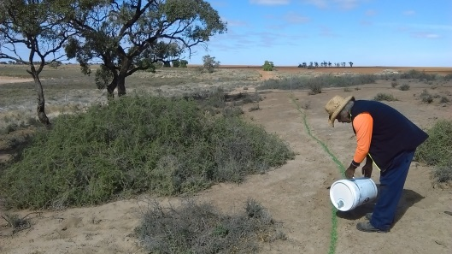](https://ecodata.ala.org.au/uploads/2016-07/IMAG0280.jpg)

# *Pindone baiting at Lake Kelly for rabbit control*

# IMPACTS

# The Kerang Lakes have undergone significant changes in water regime since the development of the Torrumbarry Irrigation System in 1896. After the upgrading of the system in 1923, land salinisation became a major problem and shallow water tables became widespread leading to an increase in the salinity levels in many of the wetlands.

# Altered catchment hydrology has increased river flows which have caused lakes on the Avoca River to fill more frequently causing decline of Red Gum forests. Saline groundwater intrusion from local and regional groundwater tables, saline irrigation tail water disposal to wetlands and the isolation of wetlands from the natural flood flows is causing increases in lake salinity and associated changes in biota.

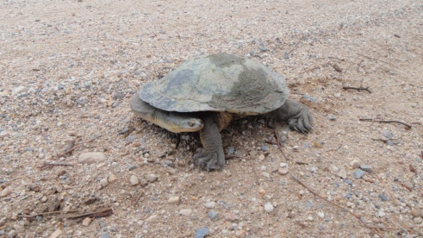

Turtles are often found on roadsides as they move between wetlands. Map turtle sightings at [www.turtlesat.org.au](http://www.turtlesat.org.au)

# Pest plants and animals in the Kerang Ramsar listed Wetlands are common, having benefited from changed land and water management in the region. There are numerous terrestrial and aquatic weed species with boxthorn, tamarisk, willow and spiny rush being most predominant. Foxes and Rabbits are ranked as a very high threat to the Kerang Ramsar listed wetlands, impacting on flora, fauna and cultural heritage sites.

# PROJECT OBJECTIVES

# The purpose of the project is to reduce the impacts of pest plants and animals on native vegetation, breeding fauna and areas of cultural heritage significance.

# https://ecodata.ala.org.au/uploads/2015-12/Planting_at_Lake_Kelly_with_Lake_Charm_primary.jpg

# **Revegetation with Lake Charm Primary School, Lake Kelly.**

# Key stakeholders and public land managers help guide the project to ensure integrated management across the project area. The working group also assists in the delivery and promotion of innovative and exciting engagement activities, which ensure the local community, is kept informed about protection activities and the values of the wetlands. Improvements in the success of waterbird breeding events and recruitment opportunities for flora species will contribute to maintenance of the ecological character of the site.

# CULTURAL HERITAGE

The Kerang Wetlands are rich in Aboriginal cultural heritage. To date, over 450 cultural heritage sites have been recorded, with a number of additional sites being identified as a result of recent surveys conducted by North Central CMA in partnership with Traditional Owners. The Wetlands provided reliable sources of water as well as a rich and diverse supply of plant and animal resources for food, medicines, shelter, clothing, and tools. The local Aboriginal community, particularly the Barapa Barapa Nation, continue to have a strong and unique spiritual connection to the area.

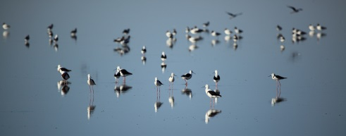

Wading birds at Lake Tutchewop.

# OUR community

# The Fairley Bael Bael Sandhill Lake Landcare group are vital partners in the annual Rabbit Buster event, held in February. The event focuses on coordinating large scale rabbit control in the region as well as providing locals with information, emerging science and control mechanisms to tackle the persistent rabbit population.

# Landcare group members receive discounted bait products provided by the Landcare group on behalf of the North Central CMA. Surrounding land managers such as Trust for Nature, and Parks Victoria undertake their baiting programs in the same time period to ensure a landscape scale, strategic approach to reducing rabbit pressure.

The community’s commitment to rabbit control around the Kerang Ramsar wetlands is vital for the protection of both public and private assets.

# OUR VALUED PARTNERS

This project has been undertaken in partnership with Goulburn-Murray Water (G-MW), Parks Victoria, local landholders, Landcare groups and Gannawarra Shire Council.

# PROJECT FUNDING

Funding for this project has been provided from the Australian Government’s National Landcare Program (NLP) and currently has a five year lifespan.

Wading birds at Lake Tutchewop.

FOR MORE INFORMATION

p: (03) 5448 7124

w: [www.nccma.vic.gov.au](http://www.nccma.vic.gov.au)

Project contact: Adrian Martins