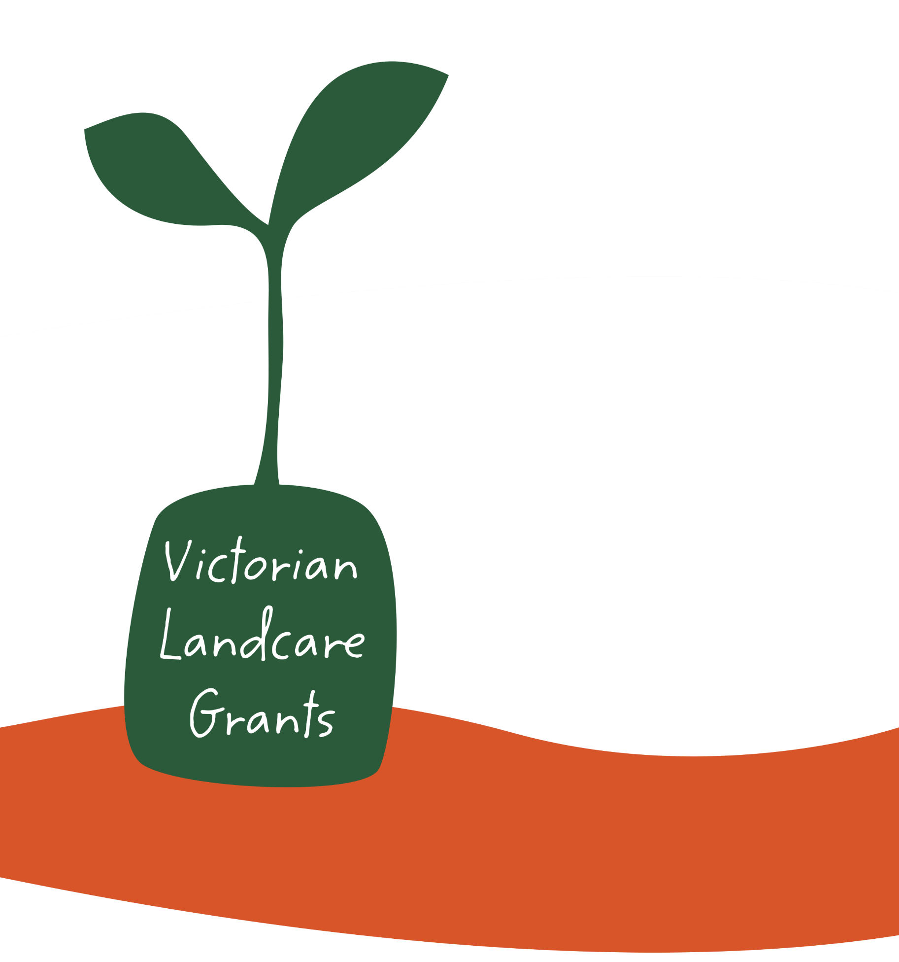

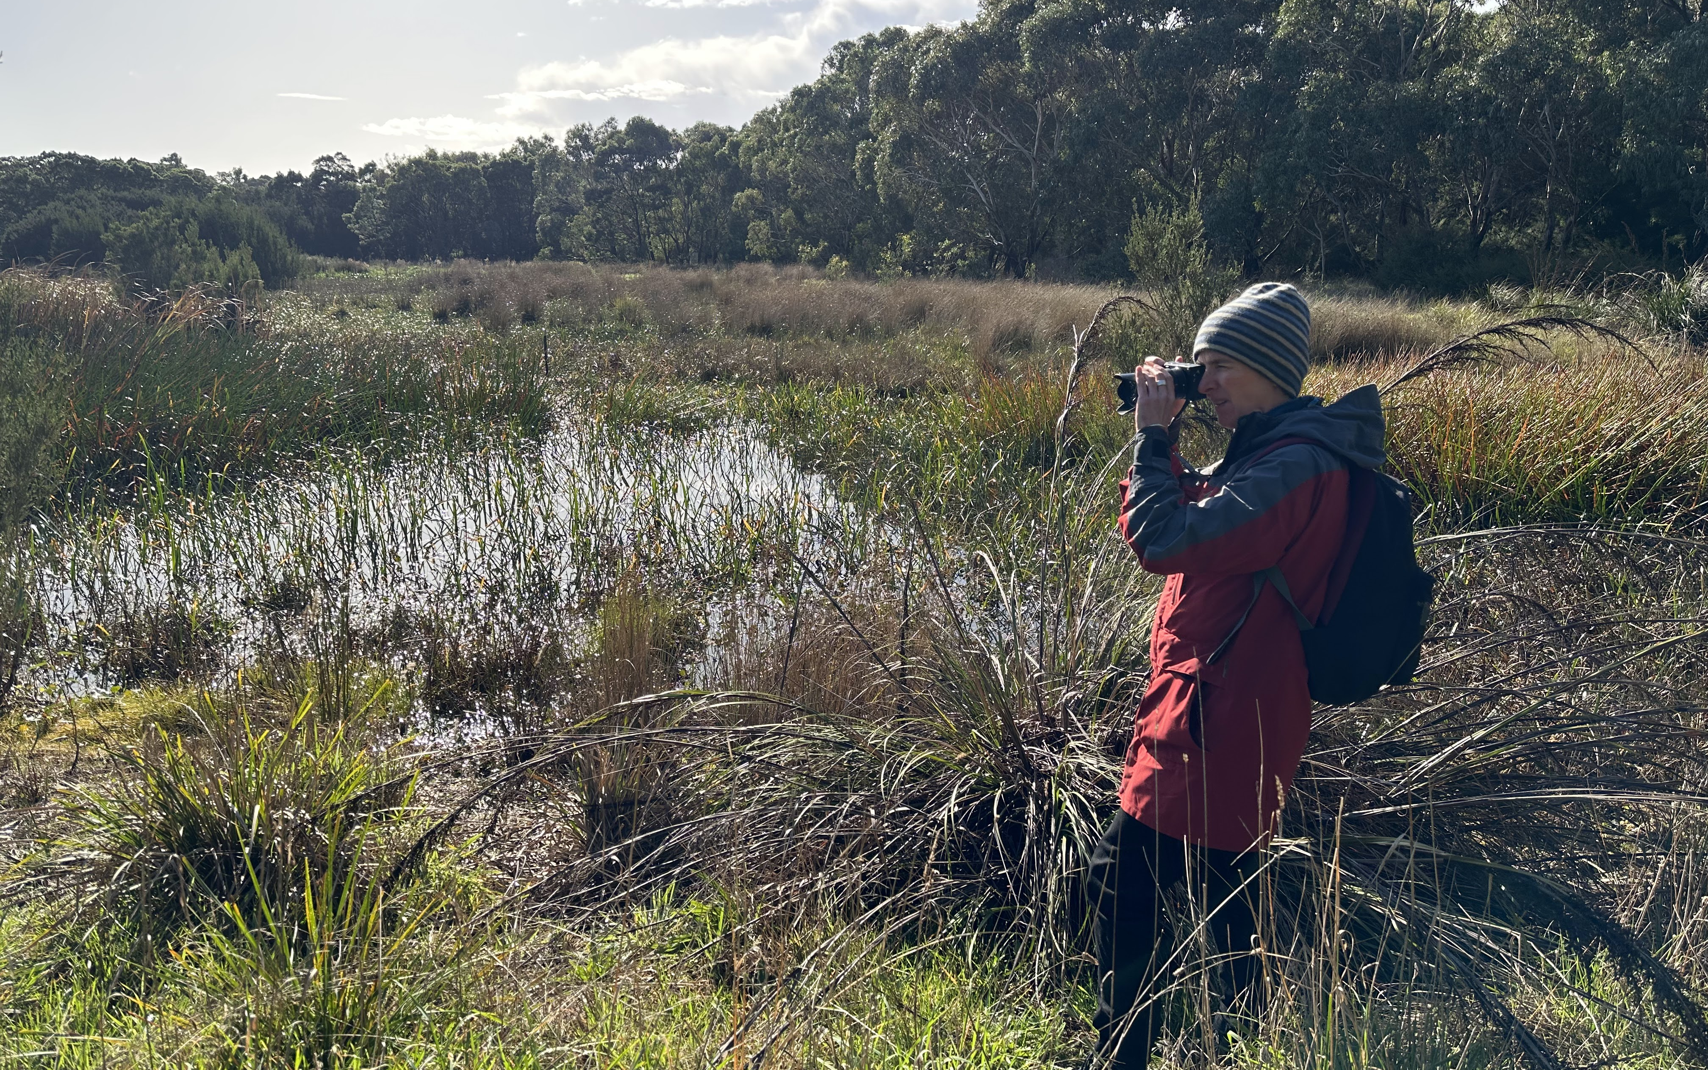

North Central CMA
Guidelines 2024

Applications close: 5pm Tuesday 30 April 2024

Acknowledgements

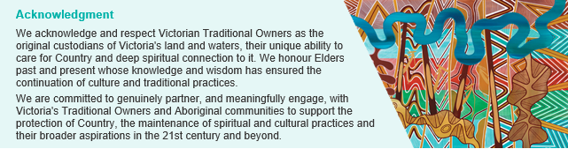

Our commitment to inclusion and diversity
The Victorian Landcare Program supports liveable, inclusive and sustainable communities. The Victorian Landcare Program supports a Landcare and environmental volunteering culture that is diverse in ability, gender, sexuality, age, socio-economic status, and cultural and linguistic background. The Victorian Landcare Program believes everyone has the right to feel safe, welcome and have their life experience valued. Fostering diversity and inclusion helps people to learn from each other and develop new ways to work effectively.

Photo Credit: Georgie Kalubowilage, DEECA
Balbirooroo Wetlands, Mornington Peninsula

Victorian Landcare Grants in North Central CMA

What are the Victorian Landcare Grants?
The Victorian Government is providing funding to support Landcare and environmental volunteer groups and networks undertaking on-ground works, education, and capability building projects to protect and restore our land and natural environment.
The objectives of the Victorian Landcare Grants are:
- To fund projects that address local, regional, and state land and environment priorities through delivery of:
  - On-ground works
  - Capability building activities
  - Community education and engagement
- To sustain Landcare and other environmental volunteer groups and networks by providing support grants, particularly for groups whose continuing existence will benefit from this support.

How much funding is available?
In 2024 a total of $3.55 million is available for the Victorian Landcare Grants program across Victoria.

What type of grants are available?
Project Grants  Up to $20,000 may be provided to eligible groups and networks for:  - On-ground works, capacity building activities, community education and engagement that protects, or improves natural assets such as native vegetation, native fauna, waterways, wetlands and soils.  Note: Projects must be completed and reported on by 30 November 2025  More than one application can be submitted. |  | Support Grants  Up to $500 may be provided to eligible groups and networks for start-up and support funding for:  - Assistance with costs such as insurance, incorporation and operational needs, meetings and events, newsletters, websites and other communication.  Note: groups and networks can apply for both Support and Project Grants, however if successful in receiving a Project Grant they will not receive a Support Grant.
To apply for a Project Grant read these guidelines before completing the application form at  https://delwp.smartygrants.com.au/NCCMAVLG2024 |  | To apply for a Support Grant complete the application form at https://delwp.smartygrants.com.au/NCCMAVLG2024

When do applications close?
Applications close at 5pm on Tuesday 30 April 2024.

Eligibility Requirements

Who can apply?
To be eligible, applicants must be:
- A Victorian Landcare or environmental volunteer group/network that is community-based and have a focus on on-ground land and natural environment improvement work. This includes Landcare groups and networks, Friends of groups, Conservation Management Networks, Coastcare groups, Committees of Management and Aboriginal groups and organisations working on Country.
Additionally, eligible applicants must be either:
- An incorporated association registered through Consumer Affairs Victoria.
- Affiliated with Landcare Victoria Incorporated as a member group.
- Registered as a not-for-profit organisation with the Australian Charities and Not-for-profits Commission (ACNC).
- An incorporated association registered through the Office of the Registrar of Indigenous Corporations.
Applicants must also:
- Hold insurance sufficient to safeguard volunteers and participants involved in the funded activities, including public liability insurance of at least $10 million and personal accident insurance.
Groups and networks that do not meet the above requirements can still apply for funding but must operate under the auspices of a sponsor organisation that meets these requirements. You will be required to supply written approval (such as supporting letter) from your sponsor (auspice) as part of your application. See ‘Do we need a sponsor (auspice)’ on page 10.

Who cannot apply?
Ineligible applicants include Commonwealth Government agencies, private companies, private individuals, Catchment Management Authorities, industry bodies, State Government statutory bodies/authorities, water authorities and Local Government.
Previous recipients of VLG funding with outstanding reporting requirements are ineligible for further funding until reporting requirements are met.

2024 Group Health Survey
All groups that apply for a project or support grant must complete the 2024 Group Health Survey as part of the application form.
The information provided by this annual survey is vital for understanding the health of Landcare and other environmental volunteer groups and networks across Victoria and is used in Catchment Management Authority (CMA) and Victorian Government planning, reporting and communications.

Project Grant Requirements

What will be funded?
These grants will fund projects up to $20,000 that:
- Are delivered within the North Central CMA region.
- Deliver activities to protect or improve natural assets such as native vegetation, native fauna, waterways, wetlands and soils including:
  - On-ground works such as weed control, pest plant and animal control, protective fencing, revegetation, artificial habitat creation, soil stabilisation (conditions apply to some works – see ‘What will not be funded’ below)
  - Community capability building, education and engagement activities such as property planning courses, field days, education events, demonstration sites, knowledge-gathering (e.g. surveys)
- Meet the following conditions:
    - Project management costs do not exceed 15% of the total funding requested. Project management costs must be specific to the project and may include salary for paid project manager/ officer, project organisation and delivery, project reporting, printing, office space and the like.
    - Total cost of capital items and equipment are not to exceed $3,000. You will need to demonstrate a clear need and community benefit for any capital items included in your budget. Capital items will need to become a registered asset of the applicant group or auspice organisation.
    - Group operating costs up to $500 may be included as a separate budget line in your project, e.g. costs such as insurance, incorporation and operational needs, or meetings, events, newsletters, websites and other communication.
- Ensure health and safety, cultural heritage and biodiversity impacts have been considered, particularly for eligible activities that have the potential for harm such as warren/den ripping.
- Can be completed and reported on no later than 30 November 2025.
More than one project grant application can be submitted by a group/network.
Value for money will be considered in the assessment process. You will need to demonstrate that all activities and budget items are necessary for the success of the project and that the amounts requested are reasonable. Projects that include in-kind contributions including time, resources or funds will demonstrate greater value for money.
It is recommended that projects are designed to be scalable to allow partial funding in the event that full funding is not available for all projects. Generally, higher scoring projects will be funded, however the Regional Assessment Panel will also consider:
- overall mix of project types, locations, and geographic coverage
- overall mix of groups/networks to be supported.
Contact your Regional Landcare Coordinator (details below) to discuss your project before submitting an application. They will provide further advice and guidance on regional priorities to help you prepare your application.

What will not be funded?
The following activities will not be funded:
- Amenity and beautification projects.
- Shooting, poisoning, trapping, explosive or fumigation* methods for pest animal control. This includes engaging a contractor to undertake these activities.
- Boundary fencing.
- Barbed wire fencing.
- Non-indigenous vegetation.
- Vegetation corridors less than 10 metres wide. Minimum project width of 10 metres is required (minimum 10 metres from the top of the bank in riparian areas).
- Control of some weed species. Applicants are encouraged to limit funding for weed control to species on the Advisory list of environmental weeds in Victoria, here. Discretion can be applied by the CMA if seen as necessary/desirable, where there is a clear public benefit to control other weed species.
- Purchase of capital items over $3,000.
- Project management or administration costs that collectively total more than 15% of total funding requested.
- Computers, laptops, and smartphones.
- Purchase of goods for competitions, prizes, giveaways, vouchers, or alcohol.
- Any other action of activity determined by the Regional Assessment Panel through the assessment process to be an inappropriate or unsuitable use of the funds.
*Please note, while ripping is still the preferred control method, fumigation for pest rabbit control may be funded if the following conditions are met:
- Works take place on public land.
- Where ripping is unable to be conducted – e.g. where there are threatened flora and vegetation communities listed under the Flora and Fauna Guarantee Act 1988 - Threatened List present.
- Written approval is provided by the Land Manager.
- Works are carried out by a contractor holding a valid Commercial Operator License (COL) and Agricultural Chemical Users Permit (ACUP).
- Preferably includes a combination of both methods, not solely fumigation.

Project location and mapping
Projects can be on private or public land in Victoria.
Applicants will need to map the location(s) of the on-ground component of their project, and label their project sites with a site ID, if working on more than one site. Applicants are encouraged to use North Central CMA iMap (NCCMA iMap3) to map their project sites and attach the map to their application. Other methods may be used providing it is clear where the project is in the landscape (for example ensure landmarks are clearly marked on the map).

Aboriginal Cultural Heritage
Aboriginal Cultural Heritage in Victoria including Aboriginal Intangible Heritage (traditional practices and knowledge), Aboriginal sites, places and objects are protected under the Aboriginal Heritage Act 2006 and Aboriginal Heritage Act Regulations 2018. It is the responsibility of us, as the carers of the land, to respect, understand, and protect our Aboriginal Heritage.
It is recommended that applicants conduct an Aboriginal Cultural Heritage check early in the planning stage. This can be done through the relevant Registered Aboriginal Party or the Aboriginal Victoria Heritage Operations Team.
To determine if your planned project is within an identified area of cultural heritage sensitivity, you will need to look at the online mapping tool, which can be found on the First Peoples State Relations website under the Heritage section.
If your proposed project site is within an area of Cultural Heritage sensitivity, please refer to the First Peoples Estate Relations website under the Heritage section for further information.
If your project is not within an area of cultural heritage sensitivity, this does not guarantee there are no Aboriginal sites in the area – If an unregistered Aboriginal site is found during the delivery of your project, you must STOP IMMEDIATELY and contact Aboriginal Victoria on 1800 762 003.
For further guidance please follow the Aboriginal Cultural Heritage Guide. If a Cultural Heritage Permit is required, you may need to include budget in your grant application and allow 30 days to complete the permit process. For more information contact your Regional Landcare Coordinator, Registered Aboriginal Party or Aboriginal Victoria.

Do I need to contribute towards my project’s budget?
You need to provide evidence of any funding you have gained from other sources and any in-kind contributions you will make to the project. This will help you to demonstrate that your project represents good value for money. Funding and in-kind contributions can include a combination of:
- Volunteer time dedicated to the project costed at $44.16 per hour (including project planning, organising and delivery).
- In-kind support e.g. photocopying, loan of equipment (at no cost), donation of materials.
- Staff time allocated to completing the project, where the salary comes from another source.
- Funding from other sources e.g. donations, philanthropic grants program.

Project assessment
Project Grant applications will be assessed by a Regional Assessment Panel. This panel will consider the contribution a project makes in terms of:
- protection and restoration of land and environment in accordance with local and regional priorities
- community engagement and capacity-building
- demonstrated need and community benefit
- project design and group/network capacity to deliver
- value for money
More details are provided in Appendix 2 on page 11.
How do I apply?
Applications are to be submitted through the online grant application system SmartyGrants. You can save your application and work on it until you are ready to submit it. We recommend that you start your application as early as possible.
Your online application can only be accessed by one set of login details. We recommend that you sign up to SmartyGrants with a generic group email, if you have one, and provide the email address and password to all individuals you wish to contribute to the application.
It is recommended that you use a computer with broadband internet access to complete your application. Computers with broadband internet are available for use at public libraries. Support in the use of computer and internet technology is also often available.
If internet connectivity is an issue in your area, a pdf of the application form can be supplied. Please contact the Regional Landcare Coordinator for your region to obtain the pdf. This will allow you to review the questions and prepare answers offline. Please note, the online form uses conditional logic, so only relevant questions will appear based on your responses, whereas the pdf contains all questions.
Hard-copy applications will not be accepted - applications must be submitted online. If working offline, you will need to copy and paste your prepared responses into the online application form to submit.
APPLY HERE https://delwp.smartygrants.com.au/NCCMAVLG2024

Questions
For any queries and to discuss your application please contact:
Belinda Pritchard
Regional Landcare Coordinator
North Central CMA
Belinda.pritchard@nccma.vic.gov.au
Phone 0408 342 593

Appendix 1: Useful information and resources

Regional Catchment Strategy
The North Central CMA Regional Catchment Strategy (Home | North Central Regional Catchment Strategy (rcs.vic.gov.au)) provides an integrated planning framework for managing land, water, and biodiversity resources, and sets out regional objectives and priorities for their protection and improvement. Applicants should design their projects to make clear contributions towards Regional Catchment Strategy objectives and priorities.

Protecting Victoria’s Environment – Biodiversity 2037
Protecting Victoria’s Environment – Biodiversity 2037 is Victoria’s plan to stop the decline of our native plants and animals and improve the natural environment, so it is healthy, valued and actively cared for. Find out more about how the plan is being implemented here.
Naturekit is a free online mapping and data exploration tool that displays biodiversity information and supports investment and management decisions to deliver Biodiversity 2037. It includes the Strategic Management Prospects (SMP) decision support tool. SMP assesses the cost-effectiveness of landscape scale actions across Victoria and compares the benefit these actions will have for the species at each location, helping to inform priority actions. To do this, it combines evidence-based models for thousands of plant and animal habitats, major threats to their survival, and indicative costs of management. SMP can be a useful resource when considering the potential biodiversity benefits of landscape-scale management actions at a location.

Biodiversity Response Planning - Focus Landscapes
Applicants are encouraged to consider the Focus Landscapes maps and fact sheets prepared by Department of Energy, Environment and Climate Action (DEECA) regional staff with stakeholders in 2020. Biodiversity Response Planning is an area-based planning approach to biodiversity conservation in Victoria.
Use the link below to locate your project in or near a Focus Landscape.
Fact Sheets are available that describe each Focus Landscape, including the species or communities that occur there, threats, and actions to take that will achieve the most outcomes for biodiversity in that landscape. Use the Fact Sheets to help design your project.
The Fact Sheets and Focus Landscapes Interactive Map can be found on the Biodiversity Response Planning – Working together for biodiversity website.
Volunteering for Nature – Environmental Volunteering Plan
The Volunteering for Nature – Environmental Volunteering Plan (2018) addresses the opportunities, challenges and changing needs of the environmental volunteering sector to help volunteers do more for nature when, where and how it suits them.

Invasive Plants and Animals Policy Framework

The Invasive Plants and Animals Policy Framework represents the Victorian Government's approach to managing existing and potential invasive species across the state. The framework expands the Victorian Government’s vision for what invasive species management can achieve for the Victorian community. For more information about declared noxious weeds and pest animals, please visit the Consolidated lists of declared noxious weeds and pest animals website and the Advisory list of environmental weeds in Victoria here.

Aboriginal Cultural Heritage Resources
Recipients must meet the requirements of the Aboriginal Heritage Act 2006 and determine if a Cultural Heritage Permit is required. Find more information at the links below.
Aboriginal Cultural Heritage Guide
Cultural Heritage Sensitivity
Online Map Tool
Registered Aboriginal Parties

Occupational Health and Safety
You must have a safe system of work in place for your project to protect the health and safety of your group, volunteers, and anyone else on your project site.
You can find resources on OHS tailored to community groups on:
- Victorian Landcare Gateway
- Victorian Workcover Authority

Landowner and land manager support
All projects that involve on-ground works will need support from the landowner or land manager.
Projects that involve events or community activities also require landowner approval.
If your project is on land owned or managed by more than one organisation or person, you will need support from each separate landowner or land manager.
Public land – including Parks Victoria, local council, and DEECA. For the grant application, a letter or email demonstrating in-principle support is sufficient. If your project is successful in receiving funding, you will need to seek formal approval before works start. Formal approval may take time – ensure you have taken this into account when designing your project. Check whether any permits are required and whether there will be a cost for this.
You need to provide evidence of land manager consent/support in your application. For advice about land manager consent please refer to relevant contacts for:
- parks and reserves contact Parks Victoria on 13 1963 or your local Parks Victoria staff
- Crown land contact DEECA on 136 186 or through your local DEECA office
- Contact the relevant local government authority
Private land - you will need to list landowner details (name and address) in your application for all private properties where on-ground works will be taking place. If your application is successful, you will be required to confirm that you can provide, upon request, evidence of private landowner's consent for on-ground works to take place.

Fencing Standards
Please check that your application meets the standards set out in the Output delivery standards for the delivery of environmental activities (PDF, 1.4 MB)
For more information visit https://www.deeca.vic.gov.au/output-data-and-delivery-standards

Child Safe Standards
Child Safe Standards apply in Victoria. The Victorian Government has zero tolerance for child abuse and is committed to ensuring the safety of children and takes deliberate steps to protect children from physical, sexual, emotional, psychological, and cultural abuse, and neglect and create a culturally safe environment for all children.
Organisations operating in Victoria, including community‐based organisations, that provide service or facilities where children are involved are required to meet Child Safe Standards. More information on the child safe standards can be found on the Commission for Children and Young People website.

Coronavirus (COVID-19)
We ask that you continue to follow public health measures, advice and restrictions when planning and implementing your project. Stay informed at coronavirus.vic.gov.au.

Do we need a sponsor (auspice)?
Applicant organisations who do not meet the eligibility requirements, as stated in these guidelines, will need to partner with another organisation, known as an auspice, to act as a project sponsor organisation.
Applicant organisations will need approval from the sponsor organisation before applying for a Victorian Landcare Grant, as that organisation will be legally responsible for delivery and administering the grant on behalf of the applicant.
If your application is successful, the sponsor organisation will be required to sign the funding agreement and manage the grant funding.
A sponsor organisation must:
- be either an incorporated association registered with Consumer Affairs Victoria, a State Government/ statutory bodies/authority, or registered as a not-for-profit with the Australian Charities and Not for Profit Commission
- hold insurance sufficient to safeguard volunteers and participants involved in the funded activities, including public liability insurance of at least $10 million and personal accident insurance
- approve of the project and be willing to take responsibility for the management and safety of the volunteers and participants involved in the funded activities
- sign the funding agreement and receive the grant payment
- be responsible for the delivery and reporting on the project
Potential auspice organisations may include:
- local governments
- state government agencies, e.g. Parks Victoria
- statutory authorities
- umbrella not-for-profit associations, e.g. Landcare Victoria Incorporated, or community networks in your area
Applicant organisations who meet all the eligibility criteria on their own do not require an auspice.

Incorporation or registration to meet eligibility requirements
Your organisation may become:
- affiliated with Landcare Victoria Incorporated as a member group. For more information contact Landcare Victoria Incorporated on P. 9207 5527 F. 9207 5500 E. mailto:info@landcarevictoria.org.au
- an incorporated association registered through Consumer Affairs Victoria.
- registered as a not-for-profit organisation with the Australian Charities and Not-for-profits Commission
- an incorporated association registered through the Office of the Registrar of Indigenous Corporations.

GST
The maximum grant available for a project is $20,000 GST free.
All CMA payments require payment of GST to GST registered organisations.
As an example, two groups apply for a $20,000 grant.
Group A is not registered for GST and Group B is registered for GST. Group A will invoice the CMA and receive $20,000. Group B will invoice the CMA for $22,000 (inc. GST) and claim a GST credit back through the ATO.
A group or network will need to work out the costs of the project that need to be funded by the grant (to a maximum of $20,000). This may include taxable supply items such as plants and materials which include a GST charge. In the project budget you will need to include each item for which you are requesting grant funding and its total cost.
Appendix 2: How will applications be assessed?
Eligible Project Grant applications will be assessed by a Regional Assessment Panel against the criteria below.

Assessment criteria

Table 1. Assessment Criteria Project Grants
Criteria | Value | Description
Land and environment outcome | 20% | The extent to which the project contributes to protection and restoration of land and environment.
Community engagement and capability building | 20% | The extent to which the project engages and builds on the capability of the group and/or volunteers and/or Traditional Owners and Aboriginal Victorians and/or land managers and/or broader community.
Demonstrated need and community benefit | 20% | Alignment with a natural resource management strategy or plan or other statement identifying the need for this project or activity and the community benefit to be delivered by the project. The extent to which the project contributes to local and regional priorities as set out in the Regional Catchment Strategy.
Project design and group/network capacity | 20% | The capacity of group/network to plan and deliver the project including group resources and technical feasibility of the project. Priority will be given to eligible projects that are well-planned and achievable. The track record of the applicant group in delivery of projects including accurate and timely reporting, mapping of outputs and communication will be considered.
Value for money | 20% | The budget demonstrates that the application represents good value for money, including realistic costs and a clear justification for requested budget items.
In addition to the above criteria, the Regional Assessment Panel will also consider:
- overall mix of project types, locations and geographic coverage
- overall mix of groups/networks to be supported
What happens after applications close?

Assessment process
The Regional Assessment Panel will assess your application based on the information received in your application.
The panel may decide to recommend partial funding of some project and support grants.
If you apply for more than one project and one of your projects is funded, preference may then be given to unfunded applicants over your other projects.

Notification of outcome
You will be advised of the outcome of your application in writing after the assessment process is completed. All decisions are final and are not subject to further review. However, applicants who are not granted funding are welcome to ask for feedback on their application.

If your application is successful
If your organisation is successful then you will have four weeks after receipt of the letter of offer, including the funding agreement, to submit your organisation’s signed funding agreement, and any other documentation outlined in the letter of offer. If the documentation is not submitted within this timeframe, the funding may be reallocated to other projects.
Successful applicants will receive payment once all paperwork has been completed and submitted. If you have an auspice, they will receive the payment on your behalf.

Funding conditions
Successful applicants and sponsor organisations (if an auspice is used) are required to:
- Enter into a funding agreement with the CMA
- Be responsible for meeting contractual obligations to deliver the project and submit project reports by 30 November 2025
- Adhere to all relevant legislation including Occupational Health and Safety requirements
- Acknowledge the CMA and Victorian Government funding in publications and promotions
- Confirm that the activity does not include using the Funding for political campaigning or advocacy activities for political parties

Reporting Requirements
You will need to provide a report on completion of the project using the reporting template provided. Reporting will be completed online using SmartyGrants, and the reporting template will be open during project delivery.
The reporting requirements will include:
- how you spent the grant
- what you achieved with the funding for the protection and restoration of land and environment
- data that you collected during the project (note - data may be made publicly available)
- what you learnt while completing the project
- how the project will support the group, network, or partnership into the future
- providing images of the project, including on-ground works and /or capacity building activities and/or community education and engagement activities (note – images may be made publicly available and will require consent release forms)
- mapping the outputs of the project using the North Central CMA’s iMap tool NCCMA iMap3 (support is available through Regional Landcare Coordinator Belinda Pritchard)

