2018-19 Victorian Landcare Grants
Reporting phase: Step-by-Step Mapping instructions

All funded activities (outputs) should have been mapped upon application (including events, plans, publications, fences, weed control and revegetation.)

Mapping is essential to record where in the landscape your proposed works will occur. Mapping is also the method used to capture the details of your proposed activities at site level. (e.g. Km’s of fencing, Hectares of revegetation, type and number of engagement events).

This mapping program calculates the area, or length of fence, for each of your outputs, allowing you to accurately record what you did where. Your data is data used by the CMA’s and DELWP.

The mapping you submitted with your grant application will be transferred into a reporting map, meaning you will not have to map these details twice.

Please either
- Confirm the details of your mapped outputs (based on your application data)
OR
- Edit/create new outputs that demonstrate what you did in your project.

If you have issues at any stage, please contact Beck Horsburgh (GIS Administrator) on (03) 5440 1819 or rebecca.horsburgh@nccma.vic.gov.au

Getting started

- Go to our iMap online map –
http://map.nccma.vic.gov.au/external/?viewer=public#

- This page will open like this

- Open the Layers tab, on the bottom left hand menu

- Select the ‘Landcare Reporting’ Layer from the blue drop down menu

You will now see all the mapped outputs from other groups, please respect them.

- The map layer is now available for you to view and edit your activities.

- Zoom into your project location by:
- Using the zoom tools (top menu bar) or scroll on your mouse.

- Editing outputs

- Click onto the feature you wish to edit. A Summary Box will appear with details of the activity.
- If it remains accurate- click confirm completion
- If it needs editing- click edit feature on the bottom right

- Adding outputs

To add outputs to the map, you need to ‘Create a feature’

- Use the selection arrow to select the activity you want to map
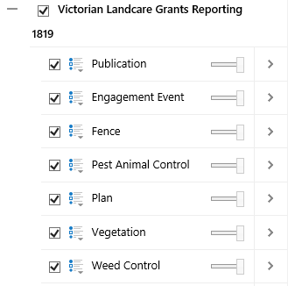

- Then select “Create a Feature”
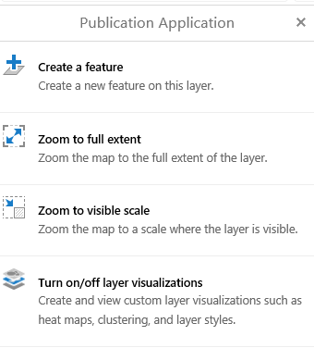

- Select the ‘Completed’ Icon, then click or tap on the map to ‘pin’ or ‘draw’ the feature in the right location.

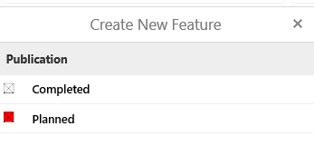
- Fill in the data table (feature attributes) that pops up when you draw the feature on the map.

Ensure you click SAVE

Repeat this process for every activity you delivered in your project.

- Attaching the map to SmartyGrants

- Once you’ve mapped all the activities you’re seeking funding for, you’re ready to ‘Print’ the map

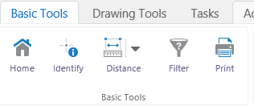
- The ‘Print’ function creates a PDF of the map for you to save on your computer then and attach to your acquittal in SmartyGrants. It does not mean you print it physically.

- Deleting outputs
If you make a mistake, no worries, you can edit or delete your outputs.

- Click onto the ‘Identify’ tool. Select the output you WANT TO EDIT OR DELETE.
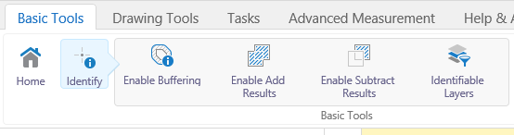
- A results menu will appear. Click on the arrow and ‘Confirm Completion’. At the bottom of the table you can DELETE the output.
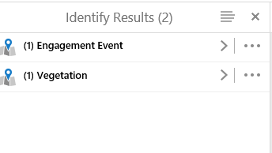
- When deleted the icon you mapped will disappear from screen.

CAUTION: It is vital you exercise extreme caution. All features from other applicants grant mapping is editable, so ensure you only edit your own outputs.

Other iMap functions which you may want to use…

Changing basemaps
If you would like to use a different ‘Basemap’, go to the Basemap menu (VicMap icon on bottom left of the map) and there are a number of different basemaps to choose from.

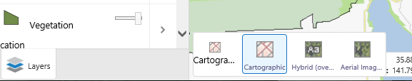

Auto-calculating feature
If you aren’t sure of the quantity or size of the outputs you’ve mapped, iMap will calculate it for you.
- Step 1: Draw you activity
- Step 2: Fill in table and click SAVE
- Step 3: Use the ‘Identity’ feature in the tool bar, click back onto your mapped activity.
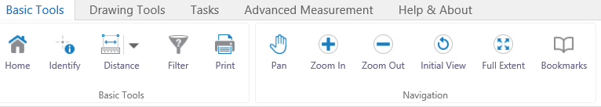
Your activity will appear in the menu on the right-hand side of screen, click the arrow and the auto calculation quantity will appear. e.g. Hectares of revegetation and weed control; Km’s of fencing.

- Step 4; Use the ‘x’ to close the menu.

Need help? Please ask. We’re here to help, please get in touch with us, or make time to come into the office and we can work on your mapping together.

