Jim Crow Creek is a 26km long ephemeral creek formed by the confluence of Sailors Creek and Spring Creek at Breakneck Gorge in Hepburn Regional Park, two kilometers north-west of Hepburn Springs in central Victoria.

The creek flows in a northerly direction from steep, forested gullies to undulating grazing land and alluvial flats where it enters the Loddon River, below the Guildford Plateau at Strangways.

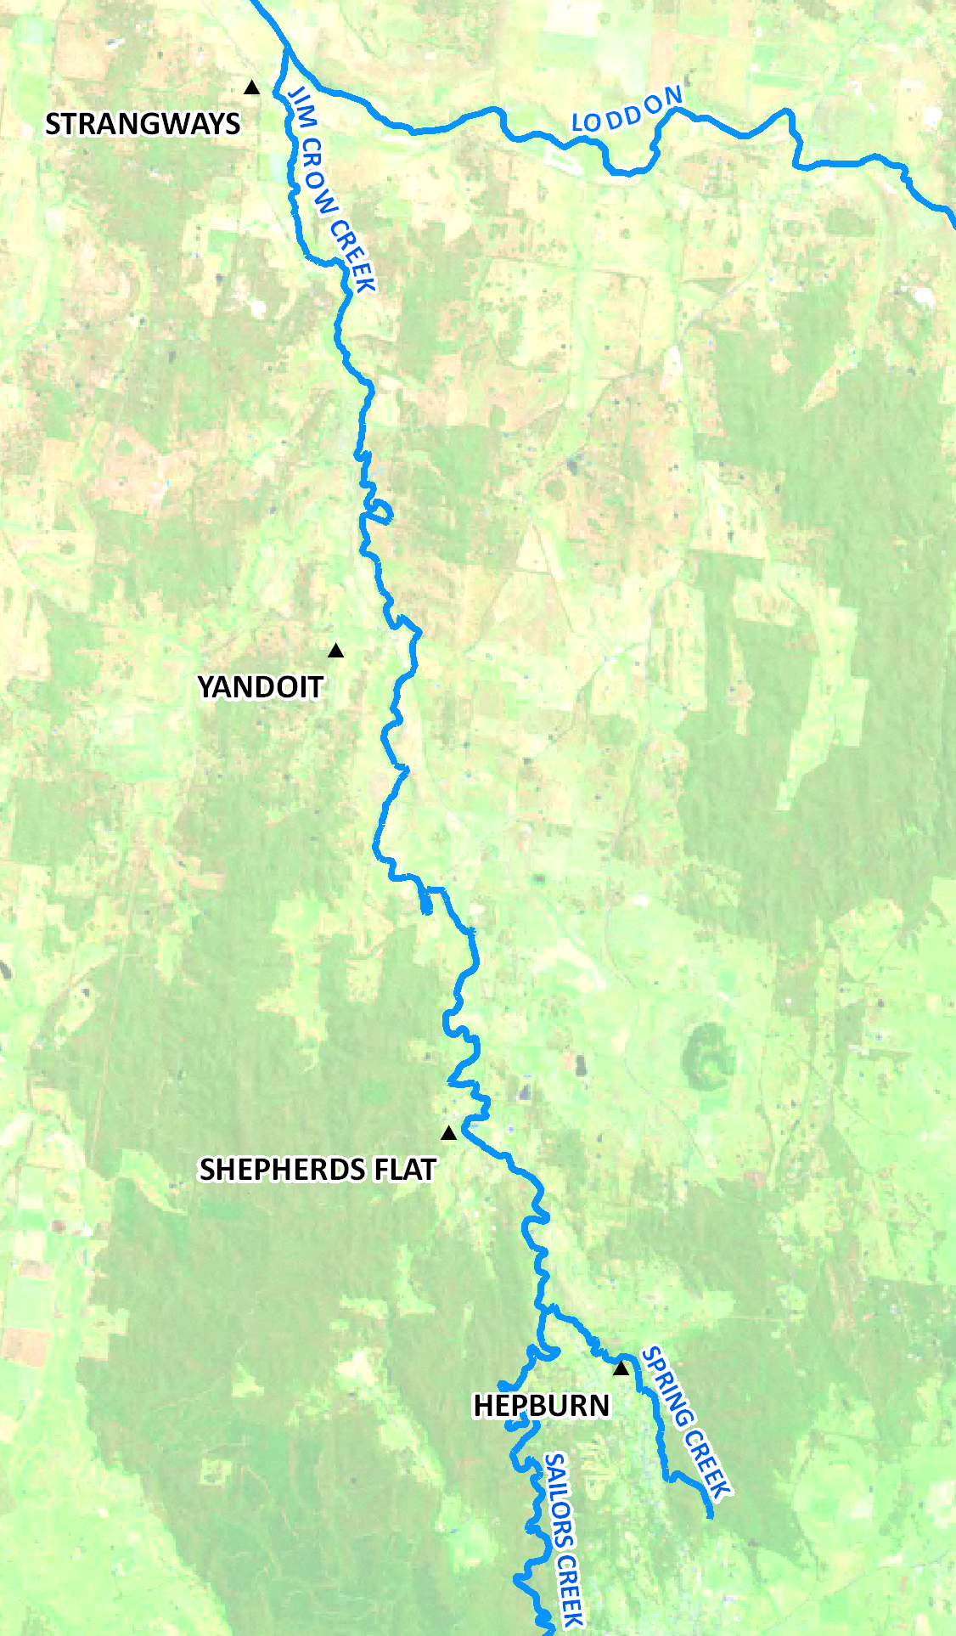
The Jim Crow Creek

The riparian zone supports a plethora of plants and animals, including a number of rare and threatened species such as the Growling Grass Frog, Swift Parrot, Brush-tailed Phascogale and Spiny Rice-flower.
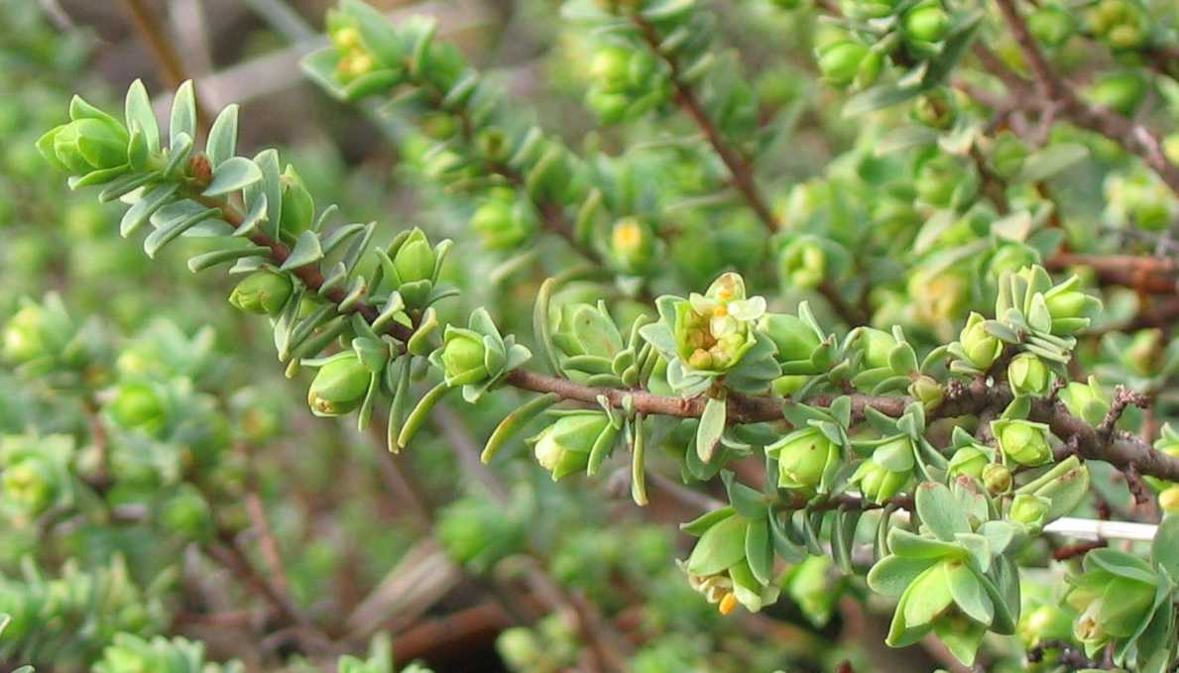
Spiny Rice Flower (threatened)
Photo: North Central CMA
The creek itself supports populations of native fish including Mountain Galaxias, Flat Headed Gudgeon, Australian Smelt, as well as exotic species such as trout and redfin.

The Jim Crow Creek is surrounded by a passionate and knowledgeable local community. Over the past decade, individuals and the Guildford Upper Loddon and Shepherds Flat Landcare groups have led onground works to protect the creek with the support of management agencies.

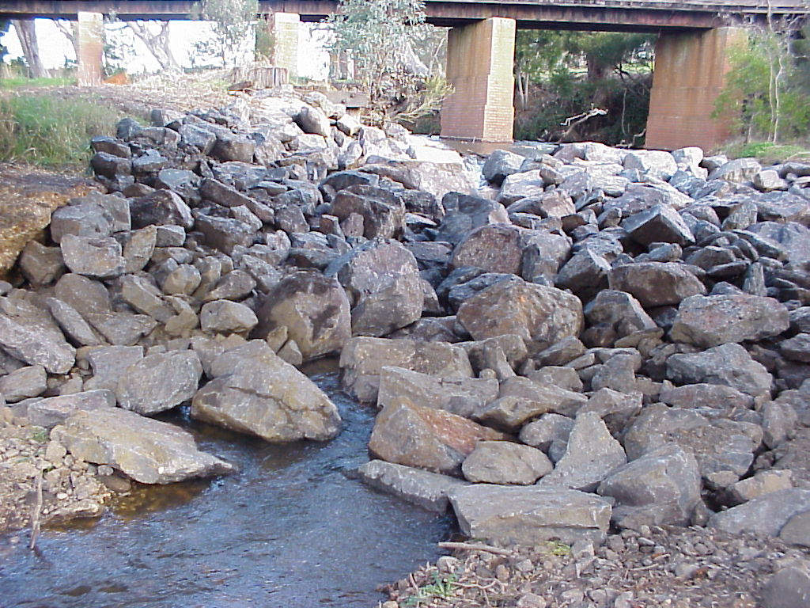
Rock chute on Jim Crow Creek, June 2002. Photo: North Central CMA

However, several threats still exist including persistent infestations of gorse and willow, and the ongoing threat of stock access in areas that are unfenced. To address these ongoing and emerging threats and to consolidate almost ten years of community and agency investment, the North Central Catchment Management Authority (CMA) are currently delivering incentives for further environmental works.

The project aims to work closely with the local community in 2010-11 to progress toward: a fully fenced Jim
Crow Creek, with remnant populations of weeds controlled to a level that is manageable by community custodians into the future, and with selective improvements made to degraded riparian areas to improve connectivity.

Funding for this project has been provided by the Victorian Government through the Natural Resources Investment Program.

The North Central CMA acknowledges the significant efforts of individuals, Landcare and community groups who have worked to protect and improve the Jim Crow Creek, and actively seeks to work alongside them to further this work.

Landholders along the Jim Crow Creek may be eligible to receive incentives to undertake weed
management, fencing and revegetation.

If you wish to find out more about this project, please contact:
Angela Gladman
North Central CMA
PO Box 18 HUNTLY VIC 3551
Phone: (03) 5440 1825
www.nccma.vic.gov.au

