Regional Roundtables

2017-18 summary
The North Central Catchment Management Authority (CMA) has a long history of creating natural resource management (NRM) partnerships and programs that deliver lasting change.
Communities are at the centre of all we do. During 2017-18 communities from across the region had opportunities to identify and discuss, through Regional Roundtable sessions, potential natural resource management project (NRM) ideas and activities.
Regional Roundtables are an initiative supported under the Victorian government’s Our Catchments, Our Communities strategy. They involve relevant government agencies and authorities, local government, Traditional Owners, Landcare and other community groups getting together to discuss what’s important in NRM across the region.
The 2017-18 Regional Roundtables were held in:
- Campbells Creek, 2 November 2017
- Kerang, 9 November 2017
- Donald, 23 November 2017

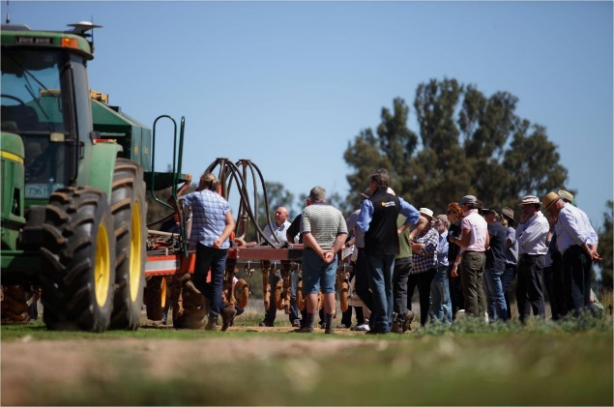

What did we hear from communities?
Valuable local knowledge and community feedback during the sessions is summarised under four themes:
- Community
  - Extension support
  - Awareness and capacity building
  - Broader engagement in NRM
  - Collaboration across agencies and groups
- Waterways, wetlands and floodplains
  - Shared benefits, such as recreation, from the delivery of water for the environment
  - Fishing and improved habitat
  - Waterway and wetland restoration
- Biodiversity
  - Greater compliance – weeds
  - Awareness and capacity building
  - Landscape scale thinking
  - Roadside vegetation management
- Land and soils
  - Sharing new information and approaches with farmers
  - Supporting innovative farmers
  - Engaging young farmers
  - Stewardship
Progress against the identified themes and community feedback, including what’s been or being done, is summarised on the back page.
More information can also be found at http://www.nccma.vic.gov.au/regional-catchment-strategy#node-1676
We want to hear from you in 2019
The North Central CMA is again heading out to communities in 2019. In addition to what we’ve already heard, we’re interested in hearing more project ideas (big and small), key gaps and further opportunities to work together and deliver lasting change.
2019 Regional Roundtable sessions (venues to be confirmed)
Kyneton, Thursday 21 February 2019
Boort, Thursday 28 February 2019
St Arnaud, Thursday 14 March 2019

Community feedback | What’s been or being done about it?
Extension support for community and Landcare to undertake native vegetation and pest plant and animal management. | - Victorian government funded Landcare Facilitators are employed by most Landcare Networks (DELWP).  - Numerous local governments have NRM officers or similar.  - Many CMA and agencies provide staff support in project areas (CMA).  - The Victorian Rabbit Action Network and similar groups are in place (DEDJTR).  - Landcare Grants are available to build capacity of local landholders (CMA).
Undertake activities to engage people, especially younger people, in NRM. Help different groups ‘adopt’ assets. | - Waterwatch’s River Detectives program is a school-based program that teaches students about waterway health (CMA). The CMA is seeking funding to expand the program.  - The CMA is involved in a number of citizen science programs including the Native Fish Recovery Project working with local anglers (Kerang), working with adjoining landholders in Birch’s Creek (Smeaton) and with schools and community on the Bendigo Creek (Bendigo).
Improve collaboration (agency and community), across all aspects of NRM and increase opportunities to share information and best practices. | - Access to best practice guidance, case studies and planning information is a key component of a new online Regional Catchment Strategy, under development during 2019-20 with community sessions planned (CMA)  - The CMA and key partners such as agencies, water corporations, Traditional Owners and local government meet at a Catchment Partners Forum and have an agreement in place to coordinate sharing, planning and delivery of NRM activities.  - The Northern Rivers Roundup offers Landcare Facilitators across the Goulburn Broken, North Central and North East regions an opportunity to share knowledge and experiences. Landcare Networks provide opportunities for groups to collaborate.
Undertake restoration activities on key assets, including waterways and wetlands, native fish and biodiversity. | - The CMA in conjunction with community are implementing several waterway restoration projects: Caring for the Campaspe, Birch’s Creek restoration, Healthy Coliban Catchment, Ramsar coordination.  - The CMA, Victorian and Australian governments and philanthropic organisations provide grant programs for communities.  - The Native Fish Recovery Plan has a prioritised approach to improving native fish passage and habitat, for the northern end of the region  - The CMA in conjunction with Trust for Nature and the community are implementing the Plains Wanderer project to support the protection of essential native grasslands habitat
Deliver water for the environment in different ways or to new places. | - The CMA continues to explore different opportunities to achieve environmental outcomes from water for the environment. Opportunities for watering need to be coordinated through a legal and regulatory framework overseen by the Victorian Environmental Water Holder and Commonwealth Environmental Water Holder.
Maximise recreational opportunities, while minimising impacts | - Parks Victoria and other public land managers play a key role in this area.  - Water for the environment delivery is designed to, where possible, deliver shared benefits (cultural, recreational) on top of their environmental requirements.
Increase opportunities, support and trust in farmers as stewards and in improving management practices. | - Many regional partners, including Murray Dairy, Birchip Cropping Group and others implement projects and host field days to support and empower farmers.  - The CMA has numerous projects including Whole Farm Planning (irrigation district), Plan2Farm, Regional Agricultural Landcare Facilitator and an upcoming Regenerative Agriculture project to support and empower farmers (CMA).

Please contact the North Central CMA on 5448 7124 or email info@nccma.vic.gov.au

