Gunbower Island Community Reference Group

Terms of Reference

Last update 7 September 2018

- Background
Gunbower Forest and Gunbower Creek are recognised as high priority environmental assets within the North Central region. The North Central Catchment Management Authority (CMA) currently manages a range of projects that aim to improve the health of Gunbower Forest and Gunbower Creek.

The North Central CMA recognises that community engagement is an important aspect of delivering successful projects. The Gunbower Island Community Reference Groups (CRG) provides an important opportunity for community members and North Central CMA project staff to work collaboratively towards the implementation of projects that will benefit the Gunbower Forest and Gunbower Creek.

The current major projects being delivered in the Gunbower Island region are:

- The Living Murray project, which aims to maintain and improve the health of river red gums, wetlands and wildlife of Gunbower forest and Gunbower creek through the delivery of environmental water.
- The Gunbower and Lower Loddon Native Fish Recovery Plan aims to improve waterway health and increase native fish populations within the Torrumbarry Irrigation District. The Plan addresses three key factors on the decline of native fish populations and species: loss of connectivity for fish movement and migration, alteration of natural flows regimes and loss of habitat.

Along with these three major projects there are a range of other projects that the CMA is currently, or in the future will be delivering in and around the Gunbower Forest and Gunbower Creek.

- Purpose
The Gunbower Island CRG has been established as the primary mechanism for engaging the community on the major environmental projects listed above which includes Seasonal Watering Proposals developed under The Living Murray program. The Gunbower Island CRG plays a critical role in ensuring the North Central CMA develop and implement projects in balance with local knowledge and communicate project ideas, progress and outcomes with the broader community. It will also enable the local community to have a better understanding of the projects and initiatives being proposed and delivered in and around the Gunbower Forest and Gunbower Creek.

CRG members can provide feedback to the North Central CMA about the effects of environmental watering events and other NRM projects as they occur, and can help to explain the purpose and effect of environmental watering and NRM actions to the broader community.

CRG members will not determine environmental water requirements for any waterway. Those requirements will be determined by scientists with specialist skills in environmental water, ecology, geomorphology and hydrology. CRG members may however provide advice on how recommended watering events can be delivered in a way that either enhances or minimises disruption to social and economic activities in the catchment. For example, CRG members may advise how a recommended autumn or spring high flow could be scheduled to avoid disrupting significant local events (e.g. increased visitation during the Easter holiday period or a community festival) or critical farming activities.

- Objectives
The objectives of the Gunbower Island CRG are to:
- Provide a forum for local knowledge and perspectives to be heard and taken into consideration when planning and implementing North Central CMA projects, including seasonal watering proposals;
- Provide direct links between the North Central CMA and the local community, in particular linking with existing community groups;
- Broaden the exposure of North Central CMA in the local community;
- Increase the local community’s knowledge and understanding of North Central CMA projects.
- Improve the North Central CMA’s knowledge of historical activities and local thoughts and ideas.

- Membership
The North Central CMA will approach the following groups and invite them to play an active role in the Gunbower Island CRG:
- North Central CMA, Community Consultative Committee
- Torrumbarry Water Services Committee
- Cohuna Lions club
- Cohuna Progress Association
- Koondrook Progress Association
- Gunbower Progress Association
- Country Fire Authority
- Leitchville-Bunyip group
- Barham and/or Gunbower Recreational Angling Club
- Cohuna Water Ski Club
- Bird observers club
- Bar-rook Field and Game
- Gannawarra Shire Councilor
- Local area farmers
- Traditional Owners
- Gunbower Creek landholders

The membership should include people who live and or work in the region and are:
- Knowledgeable about the environmental, social and/or economic values of the system
- Passionate about achieving good environmental and community outcomes for the system
- Committed to understanding issues relating to environmental water management
- Interested in strengthening relationships between the agencies responsible for managing and delivering environmental water, local communities and relevant interest groups
- Able to motivate and inform others.

It is important that the CRG includes community representatives from the whole Gunbower Island region that collectively have a detailed understanding of the whole system.

The North Central CMA will call for expressions of interest from community members who would like to join the Gunbower Island CRG. The North Central CMA may also invite community members who have knowledge of a specific area, or specific skills and experience to join the CRG to fill an identified gap in the membership. Community representatives will be asked to serve a minimum term of two years on the CRG. At the end of their term, community members may nominate to be re-appointed for a subsequent term. Ideally some community members will serve more than one term to ensure continuity within the group, and in some cases the North Central CMA may specifically invite existing members to re-nominate at the end of their term. The North Central CMA Chief Executive Officer will appoint members to each EWAG.

- Responsibilities of members
CRG members will:
- Provide knowledge, guidance and advice to the North Central CMA to enable the delivery and development of projects, including identifying constraints and opportunities;
- Provide input to the development of seasonal watering proposals
- Provide specific advice on community engagement approaches and opportunities;
- Provide a local perspective, including, historical and technical knowledge on the Gunbower Creek and Gunbower Forest;
- Provide local knowledge of the community and emerging issues;
- Provide feedback on proposed future project activities, approaches and investigations;
- Facilitate interaction and communication regarding North Central CMA projects to the wider community; and
- Provide information to the CRG on community group activities and roles that may be relevant.
Members that represent community groups have specific responsibilities including:
- Ensuring their respective community group are kept up to date regarding North Central CMA projects; and
- Facilitating interaction between the North Central CMA and their respective community group where necessary.

North Central CMA staff will:
- Retain accountability for project delivery and will use the CRG in an advisory capacity;
- Provide the CRG with at least 2 weeks advance notice of meetings;
- Maintain meeting agendas, minutes and action lists;
- Provide project updates at CRG meetings;
- Keep the CRG informed of project and funding opportunities; and
- Be responsible for all formal communications and media activity relating to North Central CMA projects.

- Expectations of members
Each of the members will be invited to have a seat on the CRG on the basis they:
- Support a collaborative approach through
  - Respect for individuals
  - Open and honest discussion
  - Working together
- Encourage innovative thinking and be open to different ways of resolving issues;
- Acknowledge that difficult discussions may take place and recommendations may need to be made;
- Provide an honest and open environment for concepts, issues and knowledge to be shared in a safe and collaborative environment;
- Treat sensitive issues discussed within the group with respect;
- Comply with specific requests from the CRG Chairperson to maintain confidentiality outside the group;
- Direct any requests for comment from the media to the CRG Chairperson or North Central CMA staff representative;
- Are punctual and make every effort to attend all meetings; and
- Do not invite community members (who are not CRG members) to attend CRG meetings without prior approval of the CRG Chairperson.

- Termination of membership
Members will cease to be a member of the CRG if they:
- Voluntarily resign, or
- Fail to attend three consecutive meetings without providing a proxy or apologies in advance, or
- Do not act within the terms of reference; or
- Are removed by way of consensus.

- Meeting details
The North Central CMA will appoint the Chairperson for the CRG. The location and starting time of the meetings will be a decision of the Chairperson upon the advice of the members.

It is anticipated that meetings will be held during normal business hours, no longer 3 hours and held every two to three months.

A draft agenda will be circulated 1 week prior to each meeting. The date of the next meeting will be confirmed at the end of each meeting.

Minutes of meetings will be taken by North Central CMA staff and circulated within 2 weeks of the meeting.

The CRG will not require a quorum as it is not a decision-making group, therefore meetings will proceed with a minimum number of attendees.

- Conflict of interest
All members of the CRG are required to declare any conflict of interest. The North Central CMA will provide information on conflict of interest at the first meeting.

If there are any declarations, working group members will follow the direction of the North Central CMA.

- Proxies
In the interests of continuity, it is preferred that a consistent representative from community groups attends meetings. However, proxies are permitted and shall have the same role as standing members.

- Remuneration
Members of the CRG will participate in a voluntary capacity. However, the North Central CMA will pay for venue hire and catering costs associated with all scheduled meetings and any relevant costs associated with field days.

The North Central CMA will reimburse community members and unpaid representatives from invited special interest groups consistent with its Reimbursement and Remuneration of Community Members policy (FIN094). This will generally extend to the issuing of fuel cards to recognise travel costs and the reimbursement of any other reasonable and unavoidable expenses.

- Appendix: Background to Seasonal Watering Proposals

The Victorian Environmental Water Holder (VEWH) is the independent statutory body responsible for holding and managing Victoria’s environmental water entitlements. The VEWH works with relevant waterway managers to ensure the environmental entitlement is used to achieve the best environmental outcome with the available water. The North Central CMA, as the regional waterway manager, engages with public land managers, storage operators, local landholders and communities to develop and implement the environmental watering program within the region. Specific responsibilities include developing annual seasonal watering proposals (SWPs) and managing the delivery of environmental water.

SWPs are developed annually and document the following for each environmental water management system:
- The volume of environmental water potentially available;
- Long-term environmental watering objectives;
- Environmental flow recommendations that aim to meet the environmental watering objectives;
- Priority watering actions;
- Scenario planning that considers current and likely future climate conditions and water availability;
- Risks associated with environmental water delivery; and
- Recommended monitoring and communications associated with environmental water delivery.
The North Central CMA undertakes community engagement on environmental water management primarily through community reference groups (CRGs) or environmental water advisory groups (EWAGs).

Priority Sites
Seasonal watering proposals are prepared for the following environmental water management systems in the North Central CMA region (see Figure 1 for specific locations).
- Coliban River
The Coliban River downstream of Malmsbury Reservoir flows for approximately 58 kilometres before entering Lake Eppalock.
- Campaspe River
The Campaspe River lies in the east of the region flowing 245 km north from its headwaters near Woodend to its confluence with the Murray River at Echuca. The Campaspe River downstream of Lake Eppalock is made up of three environmental flow reaches -Reach 2 (Eppalock to Campaspe Weir), Reach 3 (Campaspe Weir to Siphon) and Reach 4 (Siphon to Murray River).
- Birch’s Creek - Bullarook Creek
Birch’s Creek is a tributary of the Loddon River and rises on the northern slopes of the Great Dividing Range to drain a catchment area of 707km². Three reaches are considered in terms of environmental water management with flow regulated by the operation of Newlyn Reservoir. Reach 1 extends from the outlet of Newlyn Reservoir to the Hepburn Race; a distance of approximately 7.5 km. Hepburn Race to Lawrence Weir (Reach 2) is a distance of approximately 10.5 km and includes the township of Smeaton. Reach 3 is approximately 19.3 km in length from Lawrence Weir to the confluence with Creswick Creek.
- Loddon River (including Serpentine and Pyramid creeks and Boort District Wetlands)
The Loddon River system comprises six reaches of the Loddon River, from Cairn Curran to the Murray River, including Tullaroop Creek. In addition, Serpentine and Pyramid creeks and the Boort District Wetlands (Lakes Boort, Leaghur, Meran and Little Meran, and Yando Swamp) are included in this system.
- Gunbower Forest and Gunbower Creek
Gunbower Forest is a large flood dependent forest situated on the Murray River floodplain in northern Victoria between Torrumbarry and Koondrook. Covering 19,450 hectares, it is bounded by the Murray River to the north and Gunbower Creek to the south. It is an internationally significant site (Ramsar Convention) forming part of The Living Murray Gunbower-Koondrook-Perricoota Icon Site.

As the southern border to Gunbower Forest, Gunbower Creek is also a priority for watering. Gunbower Creek is 144 kilometre long anabranch of the Murray River. Twelve lagoons also feature along the creek system. Taylor’s Lagoon will be actively managed with environmental water in the near future.
- Guttrum and Benwell Forests
Located on the mid-Murray floodplain of northern Victoria, Guttrum (1,270 hectares) and Benwell (660 hectares) forests are floodplain systems within the Murray-Darling Basin. Guttrum and Benwell Forests receive flood water during high and overbank flow events in the River Murray. At present, there is no infrastructure in either forest to deliver environmental water, but temporary pumping from the River Murray is a potential option to water the semi-permanent wetlands closer to the river, such as Reed Bed Swamp and Little Reed Bed Swamp.
- Central Murray Wetlands
The Central Murray Wetland Complex consist of eight actively managed, public-land wetlands of international (Ramsar Convention) and/or regional significance (McDonalds, Johnson, Hird swamps, Lake Murphy, Lake Elizabeth, Lake Cullen, Round Lake and Richardson’s Lagoon) and one private wetland (Wirra-Lo Wetland Complex). The wetlands represent a high proportion of depleted wetland types including deep freshwater marshes and a semi-permanent saline wetland.
- Wimmera Mallee Pipeline (WMP) Wetlands
The WMP Wetland Complex is part of the Wimmera-Mallee Wetland System, which comprises 52 sites across the North Central, Wimmera and Mallee CMA regions. In the North Central CMA region, the complex consists of seven public (Creswick and Chirrip swamps, Corack Lake and Jeffcott Wildlife Reserve) and private (Davis Wetland, Fella Dam and Jesse Swamp) land sites located within the Wimmera bioregion of the Avon-Richardson Catchment.

Table 1 identifies the environmental water sources that are available for each environmental water management system in the north central region.

Table 1: Environmental water sources available for each environmental water management system
Environmental water management system | Environmental water sources
- Coliban River | - Bulk Entitlement (Campaspe System - Coliban Water) Amendment Order 2012  - Commonwealth Environmental Water Holder (CEWH)
- Campaspe River | - Bulk Entitlement (Campaspe System - Goulburn Murray Water) Conversion Order 2000  - Campaspe River Environmental Entitlement 2013  - Commonwealth Environmental Water Holder (CEWH)  - Environment Entitlement (Campaspe River - Living Murray Initiative 2007)  - Bulk Entitlement (River Murray Flora and Fauna) Conversion Order 1999  - Inter Valley Transfer: Goulburn Valley Account and Campaspe Valley Account
- Birch’s Creek-Bullarook system | - Environmental Entitlement (Birch’s Creek – Bullarook System) 2009
- Loddon River (including Serpentine and Pyramid creeks and Boort District Wetlands) | - Bulk Entitlement (Loddon River – Environmental Reserve) Order 2005  - Goulburn River Environmental Entitlement 2010  - Environmental Entitlement (Goulburn System – NVIRP Stage 1) 2012  - Commonwealth Environmental Water Holder (CEWH)  - Bulk Entitlement (River Murray Flora and Fauna) Conversion Order 1999  - Inter Valley Transfer – Loddon Inter Valley Trade Account
- Gunbower Forest and Gunbower Creek | - The Living Murray Initiative (TLM)  - Bulk entitlement (Murray River – Flora and Fauna) Conservation Order 1999  - Bulk entitlement (Murray River – Flora and Fauna) Conservation Order 1999- River Murray Unregulated Flow (RMUF)  - Commonwealth Environmental Water Holder (CEWH)  - Environmental Entitlement (Murray System - NVIRP Stage 1) 2012  - Irrigation and consumptive water on-route  - River Murray Unregulated Flows  - Private donations
- Guttrum and Benwell forests | - Bulk Entitlement (River Murray – Flora and Fauna) Conversion Order 1999 (incl. Amendments Orders and Notices 2005, 2006, 2007 and 2009)  - River Murray Unregulated Flows  - Commonwealth Environmental Water Holdings
- Central Murray Wetlands | - Bulk Entitlement (River Murray – Flora and Fauna) Conservation Order 1999  - Environmental Entitlement (Goulburn System - NVIRP Stage 1) 2012  - Environmental Entitlement (Murray System - NVIRP Stage 1) 2012  - Commonwealth Water Holdings
- Wimmera Mallee Pipeline Wetlands | - Wimmera and Glenelg Rivers Environmental Entitlement 2010
- Little Murray River | Source of water to be determined.

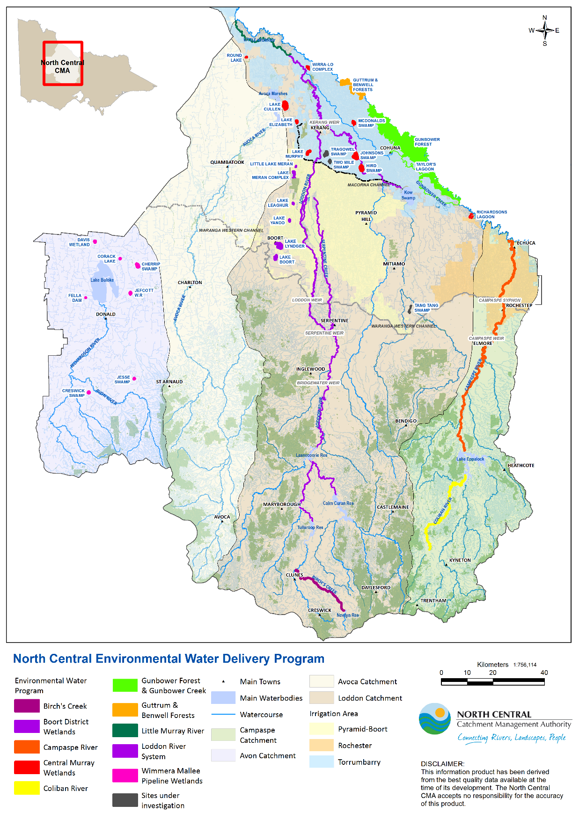
Figure 1: Map of the North Central region showing the location of each Environmental Water Management System

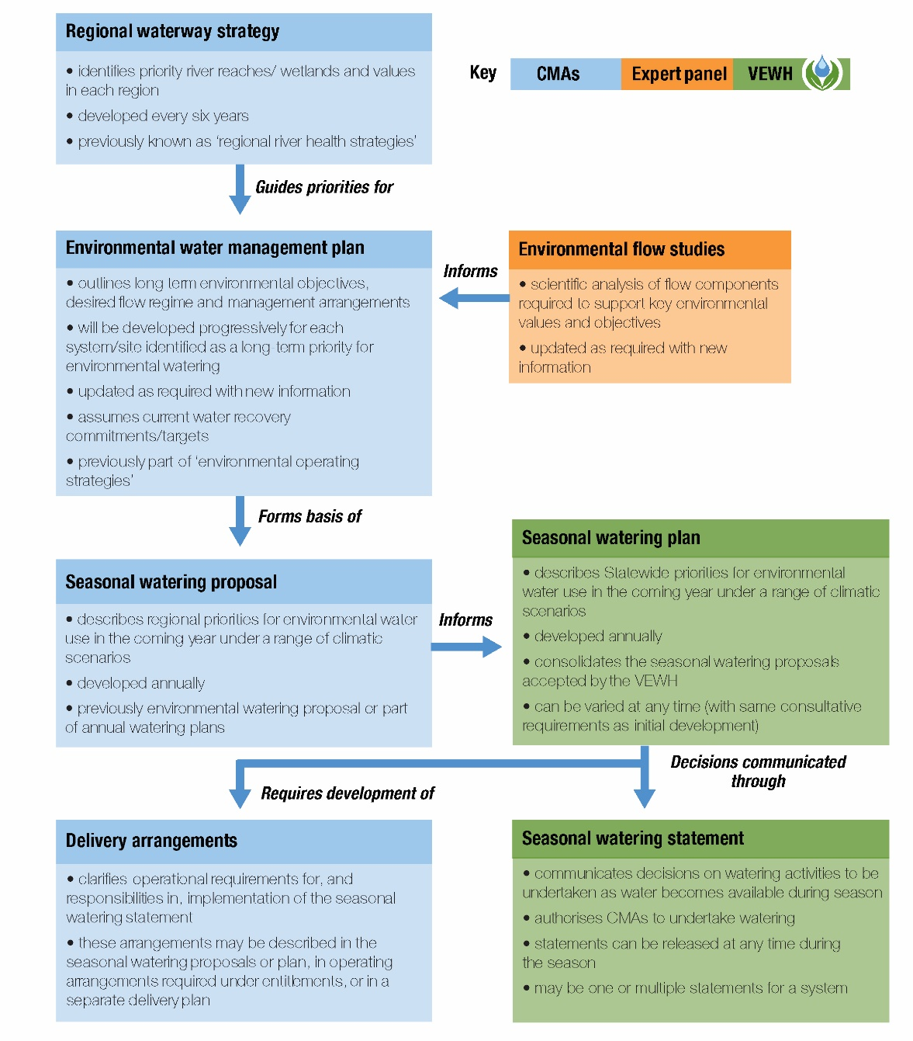
Figure 2: Victorian environmental water planning process

