2018-19 Victorian Landcare Grants
Step-by-Step Mapping instructions

All funded activities (outputs) should be mapped (recorded) including events, plans, publications, fences, weed control and revegetation.

Mapping is essential to record where in the landscape your proposed works will occur. Mapping is also the method used to capture the details of your proposed activities at site level. (e.g. Km’s of fencing, Hectares of revegetation, type and number of engagement events).

This mapping program calculates the area, or length of fence, for each of your outputs, allowing you to accurately populate the output table in the SmartyGrants application.

If you are funded, the mapping you submit with your grant application will be transferred into a reporting map, meaning you will not have to map these details twice.

If you have issues at any stage, please contact Beck Horsburgh (GIS Administrator) on (03) 5440 1819 or rebecca.horsburgh@nccma.vic.gov.au

Getting started

- Go to our iMap online map –
http://map.nccma.vic.gov.au/external/?viewer=public#

- This page will open like this
- Open the Layers tab, on the bottom left hand menu

- Select the ‘Landcare’ Layer from the drop down menu

You will now see all the mapped outputs from other groups, please respect them.

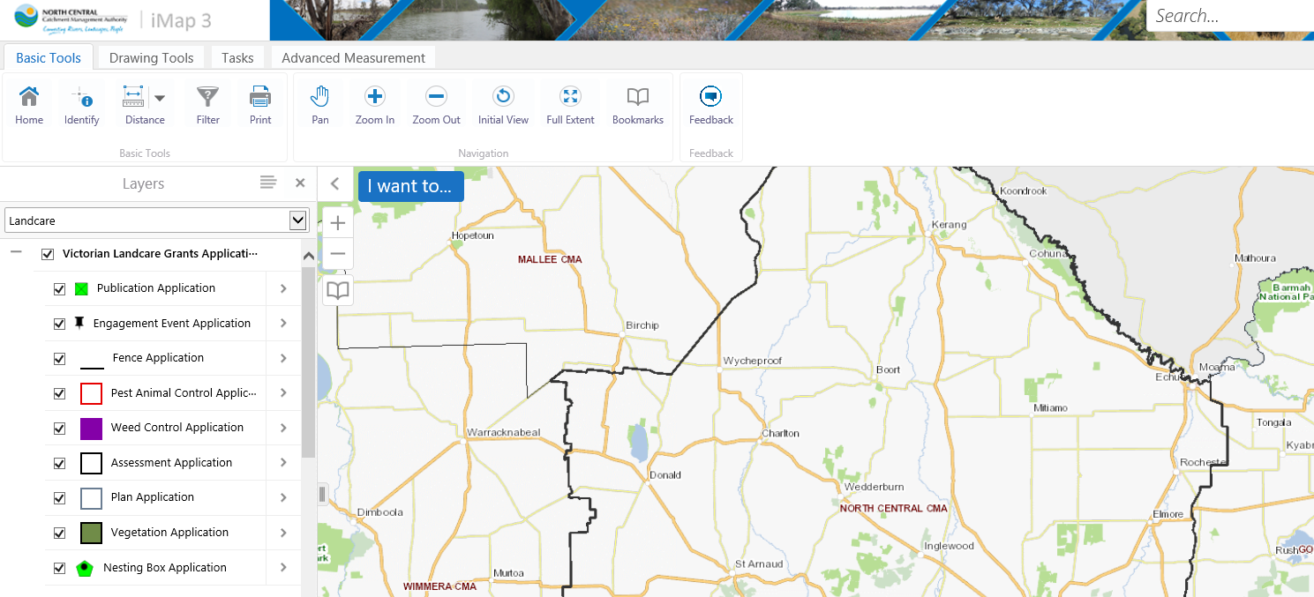
- You will see the Victorian Landcare Grants Application map layer is open for you to begin mapping.

- Find your project location by:
- Zooming to the area of interest using the zoom tools (top menu bar)

- Adding outputs

To add activities (outputs) to the map, you need to ‘Create a feature’

- From the ‘Layers’ menu view, use the arrows to choose whichever activity you wish to add to the map.

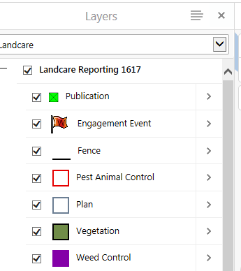

- Then select “Create a Feature”

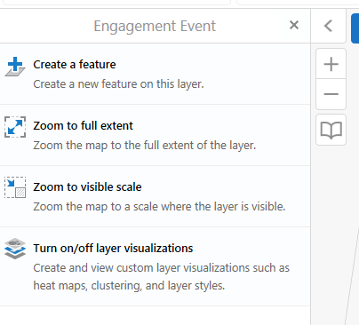

- Click back onto the map to draw/place that feature on the map and proceed to filling in the data table.

- Deleting outputs
If you make a mistake, no worries, you can edit or delete your outputs.

- Click ‘Identify’ from the Basic Tolls Menu Bar across the top of the map
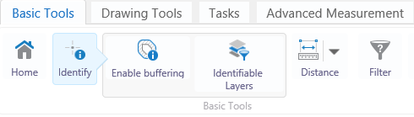

- Click the output you WANT TO EDIT OR DELETE. This menu will appear. Click ‘Edit Application’
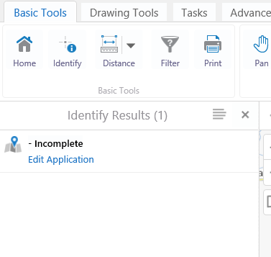
- When deleted the icon will disappear from screen.

CAUTION: It is vital you exercise extreme caution. All features from other applicants grant mapping is editable, so ensure you only edit your own outputs.

Changing basemaps
If you would like to use a different ‘Basemap’, go to the Basemap menu (VicMap icon on bottom left of the map) and there are a number of different basemaps to choose from.

Need help? Please ask. We’re here to help, please get in touch with us, or make time to come into the office and we can work on your mapping together.

Click the ‘Save’ button at the bottom of the attributes table to save your work.

