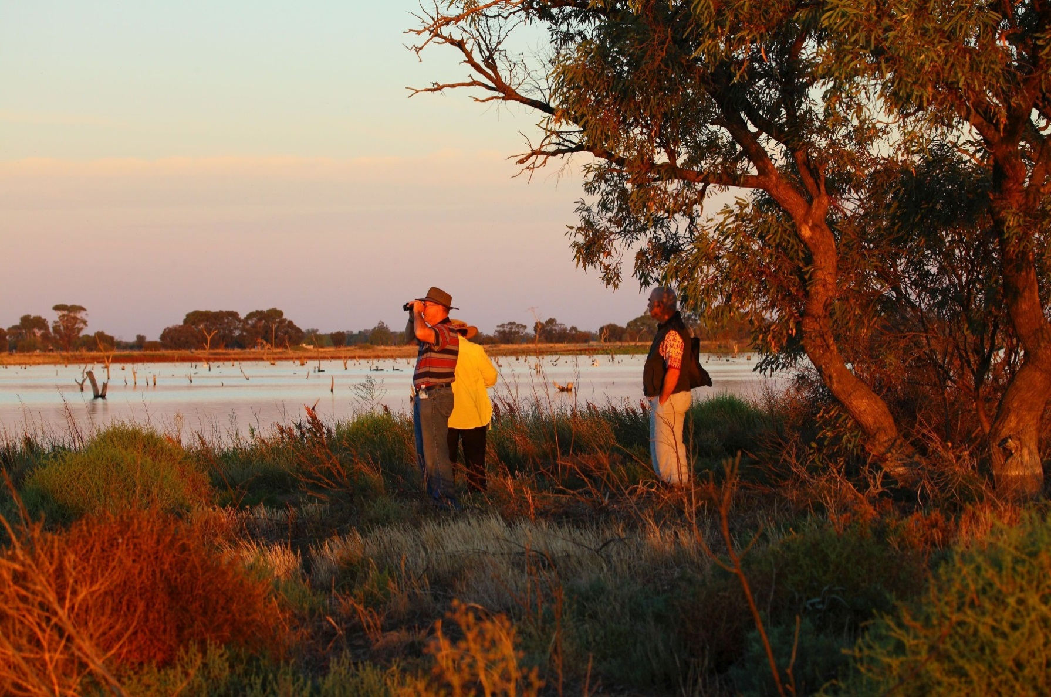

**Join us at Lake Murphy for an early morning of bird watching, expert speakers and a light breakfast. After recent deliveries of water for the environment, the wetland has become home to thousands of waterbirds including Australasian bittern. This year, participants will have to the opportunity to hear from Matt Herring of Murray Wildlife who has a wealth of waterbirds experience.**

**When**: Sunday 3 February, 2019 – 5am to 10am

**Where**: The event will be held at Lake Murphy, Dingwall. Due to limited car parking space, please enter the wetland from Bott Road and follow the signs to the carpark. Participants will be transferred by bus from the car park to the site.

**RSVP**: Registration is essential and places are limited. Please register by 1 February at [Eventbrite](https://www.eventbrite.com.au/e/breakfast-with-the-birds-2019-tickets-54626079073) (search Breakfast with the Birds 2019) or by contacting the NCCMA on 5448 7124 or info@nccma.vic.gov.au

**Bring**: Bring a hat, water bottle, reusable coffee cup, chair if required, binoculars & camera (optional). Please dress for the weather including long pants and enclosed footwear.

**Cost**: This is a FREE EVENT. Coffee, tea and a light breakfast will be provided.

In the event of extreme weather conditions, the event may be cancelled.

Why not download our citizen science app in preparation for this event? Look for NatureBlitz in your app store, or go to: [www.nccma.vic.gov.au/natureblitz-app](http://www.nccma.vic.gov.au/natureblitz-app)

This project is supported by the North Central CMA through funding from the Australian Government’s National Landcare Program

*Breakfast*

with the Birds

2019